CHAPTER XVIII.
VACCINATION A DELUSION ITS PENAL ENFORCEMENT A CRIME.
To-day, in all its dimpled bloom,
The rosy darling crows with glee;
To-morrow, in a darkened room,
A pallid, wailing infant see,
"Whose every vein, from head to heel,
Ferments with poison from my steel.
—A. H. Hume.
Against the body of a healthy man Parliament has no right of
assault whatever, under pretence of the public health; nor any the
more against the body of a healthy infant.
—Professor F. W. Newman.
I.
VACCINATION AND SMALL-POX.
Among the greatest self-created scourges of civilized
humanity are the group of zymotic diseases, or those
which arise from infection, and are believed to be due to
the agency of minute organisms which rapidly increase
in bodies offering favorable conditions, and often cause
death. Such diseases are: plague, small-pox, measles,
whooping-cough, yellow fever, typhus and enteric fevers,
scarlet fever and diphtheria, and cholera. The condi-
tions which especially favor these diseases are foul air
and water, decaying organic matter, overcrowding, and
other unwholesome surroundings, whence they have been
termed " filth diseases." The most terrible and fatal of
these—the plague—prevails only where people live
213
214 THE WONDERFUL CENTURY. chap. XVIII.

under the very worst sanitary conditions as regards ven-
tilation, water supply, and general cleanliness. Till
about 250 years ago it was as common in England as
small-pox has been during the present century, but a
very partial and limited advance in healthy conditions
of life entirely abolished it, its place being to some
extent taken by small-pox, cholera, and fevers. The
exact mode by which all these diseases spread is not
known; cholera, diphtheria, and enteric fever are be-
lieved to be communicated through the dejecta from
the patient contaminating drinking water. The other
diseases are spread either by bodily contact or by trans-
mission of germs through the air; but with all of them
there must be conditions favoring their reception and
increase. Not only are many persons apparently insus-
ceptible through life to some of these diseases, but all
the evidence goes to show that, if the whole population
of a country lived under thoroughly healthy conditions
as regards pure air, pure water, and wholesome food,
none of them could ever obtain a footing, and they would
die out as completely as the plague and leprosy have
died out, though both were once so prevalent in
England.
But during the last century there was no such knowl-
edge, and no general belief in the efficacy of simple,
healthy conditions of life as the only effectual safeguard
against these diseases. Small-pox, although then, as
now, an epidemic disease and of very varying degrees
of virulence, was much dreaded, because, owing chiefly
to improper treatment, it was often fatal, and still more
often produced disfigurement or even blindness. When,
therefore, the method of inoculation was introduced
chap. XVIII. VACCINATION A DELUSION. 215
from the East in the early part of the eighteenth cen-
tury, it was quickly welcomed, because a mild form of
the disease was produced which rarely caused death or
disfigurement, though it was believed to be an effectual
protection against taking the disease by ordinary infec-
tion. It was, however, soon found that the mild small-
pox usually produced by inoculation was quite as infec-
tious as the natural disease, and became quite as fatal
to persons who caught it. Toward the end of the last
century many medical men became so impressed with its
danger that they advocated more attention to sanitation
and the isolation of patients, because inoculation, though
it may have saved individuals, really increased the total
deaths from small-pox.
Under these circumstances we can well understand
the favorable reception given to an operation which
produced a slight, non-infectious disease, which yet was
alleged to protect against small-pox as completely as did
the inoculated disease itself. This was Vaccination,
which arose from the belief of farmers in Gloucester-
shire and elsewhere that those who had caught cow-pox
from cows were free from small-pox for the rest of their
lives. Jenner, in 1798, published his " Inquiry," giving
an account of the facts which, in his opinion, proved
this to be the case. But in the light of our present
knowledge we see that they are wholly inconclusive.
Six of his patients had had cow-pox when young, and
were inoculated with small-pox in the usual way from
twenty-one to fifty-three years afterward, and because
they did not take the disease, he concluded that the cow-
pox had preserved them. But we know that a consid-
erable proportion of persons in middle age are insus;
216 THE WONDERFUL CENTURY. chap.XVIII.

ceptible to small-pox infection; besides which, even
those who most strongly uphold vaccination now admit
that its effects die out entirely in a few years—some say
four or five, some ten—so that these people who had
had cow-pox so long before were certainly not protected
by it from taking small-pox. Several other patients
were farriers or stable men who were infected by horse-
grease, not by cow-pox, and were also said to be insus-
ceptible to small-pox inoculation, though not so com-
pletely as those who had had cow-pox. The remainder
of Jenner's cases were six children, from five to eight
years old, who were vaccinated, and then inoculated a
few weeks or months afterward. These cases are fal-
lacious from two causes. In the first place, any remnant
of the effects of the vaccination (which were sometimes
severe), or the existence of scurvy, then very prevalent,
or of any other skin-disease, might prevent the test-
inoculation from producing any effect.1 The other
1 Professor Crookshank, in his evidence before the Royal Commis-
sion (4th Report, Q. 11,729), quotes Dr. De Haen, a writer on Inocu-
lation, as saying: " Asthma, consumption, Hectic or slow fever of
any kind, internal ulcers, obstructed glands, obstructions of the
viscera from fevers, scrofula, scurvy, itch, eruptions, local inflamma-
tions or pains of any kind, debility, suppressed or irregular menstru-
ation, chlorosis, jaundice, pregnancy, lues venerea, whether in the
parent or transmitted to the child, and a constitution under the
strong influence of mercury, prevented the operation." There is no
evidence that those who applied the so-called "variolous test" in the"
early days of vaccination paid any attention to this long list of ail-
ments, many of which were very prevalent at the time, and which
would, in the opinion of De Haen, and of the English writer Sanders,
who quotes him, have prevented the action of the virus, and thus
rendered the "test" entirely fallacious. With such causes as these,
added to those already discussed, it becomes less difficult to under-
stand how it was that the alleged test was thought to prove the influ-
ence of the previous vaccination without really doing so.
CHAP. XVIII. Vaccination a delusion. 217
cause of uncertainty arises from the fact that this " vari-
olous test " consisted in inoculating with small-pox virus
obtained from the last of a series of successive patients
in whom the effect produced was a minimum, consisting
of very few pustules, sometimes only one, and a very
slight amount of fever. The results of this test, whether
on a person who had had cow-pox or who had not had it,
were usually so slight that it could easily be described by
a believer in the influence of the one disease on the other
as having " no effect"; and Dr. Creighton declares,
after a study of the whole literature of the subject, that
the description of the results of the test is almost always
loose and general, and that in the few cases where more
detail is given the symptoms described are almost the
same in the vaccinated as in the unvaccinated. Again,
no careful tests were ever made by inoculating at the
same time, and in exactly the same way, two groups of
persons of similar age, constitution, and health, the one
group having been vaccinated, the other not, and none
of them having had small-pox, and then having the
resulting effects carefully described and compared by
independent experts. Such " control " experiments
would not be required in any case of such importance as
this; but it was never done in the early days of vaccina-
tion, and it appears never to have been done to this day.
The alleged " test" was, it is true, applied in a great
number of cases by the early observers, especially by
Dr. Woodville, physician to a small-pox hospital; but
Dr. Creighton shows reason for believing that the lymph
he used was contaminated with small-pox, and that the
supposed vaccinations were really inoculations. This
lymph was widely spread all over the country, and was

218 THE WONDERFUL CENTURY. chap. XVIII.
supplied to Jenner himself, and we thus have explained
the effect of the " vaccination " in preventing the sub-
sequent " inoculation" from producing much effect,
since both were really mild forms of small-pox inocula-
tion. This matter is fully explained by Dr. Creighton in
his evidence before the Royal Commission, printed in the
Second Report. Professor E. M. Crookshank, who has
made a special study of cow-pox and other animal diseases
and their relation to human small-pox, gives important
confirmatory evidence, to be found in the Fourth Report.
This brief statement of the early history of vaccina-
tion has been introduced here in order to give what seems
to be a probable explanation of the remarkable fact that
a large portion of the medical profession accepted, as
proved, that vaccination protected against a subsequent
inoculation of small-pox, when in reality there was no
such proof, as the subsequent history of small-pox epi-
demics has shown. The medical and other members of
the Royal Commission could not realize the possibility
of such a failure to get at the truth. Again and again
they asked the witnesses above referred to to explain how
it was possible that so many educated specialists could
be thus deceived. They overlooked the fact that a cen-
tury ago was, as regards the majority of the medical
profession, a pre-scientific age; and nothing proves this
more clearly than the absence of any systematic " con-
trol " experiments, and the extreme haste with which
some of the heads of the profession expressed their belief
in the lifelong protection against small-pox afforded by
vaccination, only four years after the discovery had been
first announced. This testimony caused Parliament to
vote Jenner £10,000 in 1802.
Chap..XVIII. VACCINATION A DELUSION. 219
Ample proof now exists of the fallacy of this belief,
since vaccination gives no protection (except perhaps for
a month or two) as will be shown later on. But there
was also no lack of proof in the first ten years of the
century; and had it not been for the unscientific haste of
the medical witnesses to declare that vaccination pro-
tected against small-pox during a whole lifetime—a fact
of which they had not and could not possibly have any
evidence—this proof of failure would have convinced
them and have prevented what is really one of the scan-
dals of the nineteenth century. These early proofs of
failure will be now briefly indicated.
Only six years after the announcement of vaccina-
tion, in 1.804, Dr. B. Moseley, Physician to Chelsea Hos-
pital, published a small book on the cow-pox, containing
many cases of persons who had been properly vaccinated
and had afterward had small-pox; and other cases of
severe illness, injury, and even death resulting from vac-
cination; and these failures were admitted by the Royal
Jennerian Society in their Report in 1806. Dr. Wil-
liam Rowley, Physician to the St. Marylebone Infirm-
ary, in a work on "Cow-pox Inoculation" in 1805, which
reached a third edition in 1806, gave particulars of 504
cases of small-pox and injury after vaccination, with
seventy-five deaths. He says to his brother medical
men: " Come and see. I have lately had some of the
worst species of malignant small-pox in the Marylebone
Infirmary, which many of the faculty have examined
and know to have been vaccinated." For two days he
had an exhibition in his Lecture Room of a number of
children suffering from terrible eruptions and other
diseases after vaccination.

220 THE WONDERFUL CENTURY. CHAP. XVIII.
Dr. Squirrel, formerly Resident Apothecary to the
Small-pox Inoculation Hospital, also published in 1805
numerous cases of small-pox, injuries, and death after
vaccination.
John Birch, a London surgeon, at first adopted vac-
cination and corresponded with Jenner, but soon finding
that it did not protect from small-pox and that it also
produced serious and sometimes fatal diseases, he became
one of its strongest opponents, and published many let-
ters and pamphlets against it up to the time of his death
in 1815.
Mr. William Goldson, a surgeon at Portsea, published
a pamphlet in 1804, giving many cases in his own expe-
rience of small-pox following vaccination. What made
his testimony more important was that he was a believer
in vaccination, and sent accounts of some of his cases to
Jenner so early as 1802, but no notice was taken of
them.1
Mr. Thomas Brown, a surgeon of Musselburgh, pub-
lished in 1809 a volume giving his experiences of the
results of vaccination. He had at first accepted and
practised it. He also applied the " variolous test," with
apparent success, and thereafter went on vaccinating in
full confidence that it was protective against small-pox,
till 1808, when, during an epidemic, many of his patients
caught the disease from two to eight years after vaccina-
tion. He gives the details of forty-eight cases, all within
his own personal knowledge, and he says he knew of
many others. He then again tried the " variolous test,"

1 The cases of failure of vaccination here referred to are given in
Mr. "William White's " Story of a Great Delusion," where fuller ex-
tracts and references will be found.
CHAP. XVIII. VACCINATION A DELUSION. 221
and found twelve cases in which it entirely failed, the
result being exactly as with those who were inoculated
without previous vaccination. These cases, with ex-
tracts from Brown's work, were brought before the
Royal Commission by Professor Crookshank. (See 4th
Report, Q. 11,852.)
Again, Mr. William Tebb brought before the Com-
mission a paper by Dr. Maclean, in the Medical Observer
of 1810, giving 535 cases of small-pox after vaccination,
of which 97 were fatal. He also gave 150 cases of
diseases from cow-pox, with the names of ten medical
men, including two Professors of Anatomy, who had
suffered in their own families from vaccination. The
following striking passage is quoted: "Doctrine.—Vac-
cination or Cow-pox inoculation is a perfect preventive
of small-pox during life. (Jenner, etc.) Refutation.—
535 cases of small-pox after cow-pox. Doctrine.—Cow-
pox renders small-pox milder. It is never fatal. Refu-
tation.—97 deaths from small-pox after cow-pox and
from cow-pox diseases."
The cases here referred to, of failure of vaccination to
protect even for a few years, are probably only a small
fraction of those that occurred, since only in exceptional
cases would a doctor be able to keep his patients in view,
and only one doctor here and there would publish his
observations. The controversy was carried on with un-
usual virulence; hence perhaps the reason why the public
paid so little attention to it. But unfortunately both the
heads of the medical profession and the legislature had
committed themselves by recognizing the full claims of
Jenner at too early a date and in a manner that admitted
of no recall. In 1802, as already stated, the House of

222 THE WONDERFUL CENTURY. chap. XVIII.

Commons, on the Report of its Committee, and the evi-
dence of the leading physicians and surgeons of London
—a large number of whom declared their belief that
cow-pox was a perfect security against small-pox—voted
Jenner £10,000. When therefore the flood of evidence
poured in, showing that it did not protect, it was already
too late to remedy the mischief that had been done, since
the profession would, not so soon acknowledge its mis-
take, nor would the legislature admit having hastily
voted away the public money without adequate reason.
The vaccinators went on vaccinating, the House of Com-
mons gave Jenner £20,000 more in 1807, endowed vac-
cination with £3000 a year in 1808, and after providing
for free vaccination in 1840, made the operation com-
pulsory in 1853 by a fine, and ordered the Guardians to
prosecute in 1867.
Vaccination and the Medical Profession.
Before proceeding to adduce the conclusive evidence
that now exists of the failure of vaccination, a few pre-
liminary misconceptions must be dealt with. One of
these is that, as vaccination is a surgical operation to
guard against a special disease, medical men can alone
judge of its value. But the fact is the very reverse, for
several reasons. In the first place, they are interested
parties, not merely in a pecuniary sense, but as affecting
the prestige of the whole profession. In no other case
should we allow interested persons to decide an important
matter. Whether iron ships are safer than wooden ones
is not decided by ironmasters or by shipbuilders, but by
the experience of sailors and by the statistics of loss. In

chap. XVIII. VACCINATION A DELUSION. 223
the administration of medicine or any other remedy for
a disease, the conditions are different. The doctor ap-
plies the remedy and watches the result, and if he has a
large practice he thereby obtains knowledge and experi-
ence which no other persons possess. But in the case of
vaccination, and especially in the case of public vaccina-
tors, the doctor does not see the result except by acci-
dent. Those who get small-pox go to the hospitals, or
are treated by other medical men, or may have left the
district; and the relation between the vaccination and
the attack of small-pox can only be discovered by the
accurate registration of all the cases and deaths, with the
facts as to vaccination or revaccination. When these
facts are accurately registered, to determine what they
teach is not the business of a doctor but of a statistician,
and there is much evidence to show that doctors are bad
statisticians, and have a special faculty for misstating
figures. This allegation is so grave and so fundamental
to the question at issue that a few facts must be given
in support of it.
The National Vaccine Establishment, supported by
Government grants, issued periodical Reports, which
were printed by order of the House of Commons; and
in successive years we find the following statements:
In 1812, and again in 1.818, it is stated that " previous
to the discovery of vaccination the average number of
deaths by small-pox within the (London) Bills of Mor-
tality was 2000 annually; whereas in the last year only
751 persons have died of the disease, although the in-
crease of population within the last ten years has been
133,139."
The number 2000 is about the average small-pox

224 THE WONDERFUL CENTURY. chap.XVIII.
deaths of the whole eighteenth century, but those of the
last two decades before the publication of Jenner's
" Inquiry," were 1751 and 1786, showing a decided fall.
This, however, may pass. But when we come to the
Report for 1826 we find the following: " But when we
reflect that before the introduction of vaccination the
average number of deaths from small-pox within the
Bills of Mortality was annually about 4000, no stronger
argument can reasonably be demanded in favor of the
value of this important discovery."
This monstrous figure was repeated in 1834, appar-
ently quite forgetting the correct figure for the whole
century given in 1818, and also the fact that the small-
pox deaths recorded in the London Bills of Mortality in
any year of the century never reached 4000. But worse
is to come; for in 1836 we have the following statement:
" The annual loss of life by small-pox in the Metropolis,
and within the Bills of Mortality only, before vaccina-
tion was established, exceeded 5000, whereas in the
course of last year only 300 died of the distemper."
And in the Report for 1838 this gross error is repeated;
while in the next year (1839) the conclusion is drawn
" that 4000 lives are saved every year in London since
vaccination so largely superseded variolation." 1
The Board of the National Vaccine Establishment
consisted of the President and four Censors of the Royal
College of Physicians, and the Master and two senior

1 These extracts from the Reports are given by Mr. White in his
" Story of a Great Delusion." The actual deaths from smallpox dur-
ing the last century are given in. the Second Report of the Royal
Commission, p. 290. The extracts have been verified at the British
Museum by my friend Dr. Scott Tebb, and are verbally accurate.
CHAP.XVIII. VACCINATION A DELUSION. 225
Wardens of the College of Surgeons. We cannot pos-
sibly suppose that they knew or believed that they were
publishing untruths and grossly deceiving the public.
We must, therefore, fall back upon the supposition that
they were careless to such an extent as not to find out
that they were authorizing successive statements of the
same quantity, as inconsistent with each other as 2000
and 5000.
The next example is given by Dr. Lettsom, who, in
his evidence before the Parliamentary Committee in
1802, calculated the small-pox deaths of Great Britain
and Ireland before vaccination at 36,000 annually; by
taking 3000 as the annual mortality in London and mul-
tiplying by twelve, because the population was estimated
to be twelve times as large. He first takes a number
which is much too high, and then assumes that the mor-
tality in the town, village, and country populations was
the same as in overcrowded, filthy London! Small-pox
was always present in London, while Sir Gilbert Blane
tells us that in many parts of the country it was quite un-
known for periods of twenty, thirty, or forty years. In
1782 Mr. Connah, a surgeon at Seaford, in Sussex, only
knew of one small-pox death in eleven years among a
population of 70.0. Cross, the historian of the Norwich
epidemic in 1819, states that previous to 1805 small-pox
was little known in this city of 40,000 inhabitants, and
was for a time almost extinct; and yet this gross error,
of computing the small-pox mortality of the whole coun-
try from that of London (and computing it from wrong
data) was not only accepted at the time, but has been
repeated again and again down to the present day as an
ascertained fact!

226 THE WONDERFUL CENTURY. chap. XVIII.
In a speech in Parliament in defence of vaccination,
Sir Lyon Playfair gave 4000 per million as the average
London death-rate by small-pox before vaccination—a
number nearly double that of the last twenty years of the
century, which alone affords a fair comparison. But
far more amazing is the statement by the late Dr. W. B.
Carpenter, in a letter to the Spectator of April, 1881,
that " a hundred years ago the small-pox mortality of
London alone, with its then population of under a mil-
lion, was often greater in a six months' epidemic than
that of the twenty millions of England and Wales now
is in any whole year." The facts, well known to every
enquirer, are—that the very highest small-pox mor-
tality in the last century in a year was 3992 in 1772,
while in 1871 it was 7912 in London, or more than
double; and in the same year, in England and Wales, it
was 23,000. This amazing and almost incredible mis-
statement was pointed out and acknowledged privately,
but never withdrawn publicly!
The late Mr. Ernest Hart, a medical man, editor of the
British Medical Journal, and a great authority on sani-
tation, in his work entitled " The Truth about Vaccina-
tion," surpassed even Dr. Carpenter in the monstrosity
of his errors. At page 35, of the first edition (1880),
he stated that in the forty years 1728-57 and 1771-80,
the average annual small-pox mortality of London was
about 18,000 per million living. The actual average
mortality, from the tables given in the Second Report of
the Royal Commission, page 290, was a little over 2000,
the worst periods having been chosen; and taking the
lowest estimates of the population at the time, the mor-
tality per million would have been under 3000. This
chap. XVIII. VACCINATION A DELUSION. 227
great authority, therefore, has multiplied the real num-
ber by six! In a later edition this statement is omitted;
but in the first edition it was no mere misprint, for it was
triumphantly dwelt upon over a whole page and com-,
pared with modern rates of mortality.
Yet one more official misstatement. About the year
1884 the National Health Society, with the approval of
the Local Government Board, issued a tract entitled
Facts concerning Vaccination for Heads of Families, in
which appeared the statement, " Before the introduction
of vaccination, small-pox killed 40,000 persons yearly
in this country." We have already shown that Dr.
Lettsom's figure, 36,000 was utterly unfounded, and
probably three or four times greater than the truth.
Here we have a semi-official and widely-distributed
statement even more remote from the truth. In later
issues of the same tract this particular statement is with-
drawn, and a different but equally erroneous one substi-
tuted. Thus: " Before its discovery [vaccination] the
mortality from small-pox in London was forty times
greater than it is now." This is an altogether vague and
misleading statement. If it means that in some years of
the last century it was forty times greater than in some
years of this century, it is misleading, because even
within the last thirty years some years have a mortality
not only forty but eighty and even 200 times as great as
others. (In 1875 there were ten deaths per million,
while in 1871 there were 2420 deaths per million.) If
it means on an average of say twenty years, it is false.
For the twenty years 1869-98 the mortality was about
300 per million, while for the last twenty years before
the discovery of vaccination it was about 2000 per mil-

228 THE WONDERFUL CENTURY. chap. XVIII.
lion, or less than seven times as much instead of forty
times!
This same tract is full of other equally gross misstate-
ments. It tells us, in large, black type, " With due
care in the performance of the operation, no risk of any
injurious effects from it need be feared." The Regis-
trar-General himself shows us that this is false, in his
Report for 1895, Table 17, p. lii.:
COWPOX AND OTHER EFFECTS OF VACCINATION.

Year. | Deaths. | Year. | Deaths.
1881 | 58 | 1889 | 58
1882 | 65 | 1890 | .. 43
1883 | 55 | 1891 | 43
1884 | 53 | 1892 | 58
1885 | 52 | 1893 | 59
1886 | 45 | 1894 | 50
1887 | 45 | 1895 | 56
1888 | 45
An average of 52 children officially murdered every
year, and officially acknowledged, is termed " alleged in-
jury," which need not be feared! And these cruel
falsehoods are spread broadcast over the country, and the
tract bears upon its title-page—" Revised by the Local
Government Board, and issued with their sanction."
As the tract bears no date,I cannot tell whether it is
still issued; but it was in circulation up to the time when
the Commission was sitting, and it is simply disgrace-
ful that a Government Department should ever have
given its official sanction to such a tissue of misrepre-
sentations and palpable false statements. For these 785
deaths in fifteen years, and 390 in the preceding twenty-
two years (classed as from erysipelas after vaccination),
no one has been punished, and no compensation or even
official apology has been given to the thousand sorrow-

CHAP.XVIII. VACCINATION A DELUSION. 229
ing families. And we may be sure that these acknowl-
edged deaths are only a small portion of what have really
occurred, since the numbers have increased considerably
in the later period, during which more attention has been
given to such deaths and more inquests held. It is cer-
tain that for every such death acknowledged by the
medical man concerned, many are concealed under the
easy method of stating some of the later symptoms as the
cause of death. Thus, Mr. Henry May, Medical Officer
of Health, candidly states as follows: " In certificates
given by us voluntarily, and to which the public have
access, it is scarcely to be expected that a medical man
will give opinions which may tell against or reflect upon
himself in any way. In such cases he will most likely
tell the truth, but not the whole truth, and assign some
prominent symptom of the disease as the cause of death.
As instances of cases which may tell against the medical
man himself, I will mention erysipelas from vaccination,
and puerperal fever. A death from the first cause
occurred not long ago in my practice; and although I
had not vaccinated the child, yet, in my desire to pre-
serve vaccination from reproach, I omitted all mention
of it from my certificate of death." (See Birmingham
Medical Review, vol. iii. pp. 34, 35.) That such sup-
pressio veri is no new thing, but has been going on dur-
ing the whole period of vaccination, is rendered probable
by a statement in the Medical Observer of 1810, by Dr.
Maclean. He says: " Very few deaths from cow-pox
appear in the Bills of Mortality, owing to the means
which have been used to suppress a knowledge of them.
Neither were deaths, diseases, and failures transmitted
in great abundance from the country, not because they

230 THE WONDERFUL CENTURY. chap. XVIII
did not happen, but because some practitioners were
interested in not seeing them, and others who did see
them were afraid of announcing what they knew."
As an example of the number of cases occurring all
over the country, Mr. Charles Fox, a medical man re-
siding at Cardiff, has published fifty-six cases of illness
following vaccination, of which seventeen resulted in
death (E. W. Allen, 1890). In only two of these, where
he himself gave the certificate, was vaccination men-
tioned. All of these cases were examined by himself
personally. Among those who survived, several were
permanently injured in health, and some were crippled
for life; while in most of such cases the inflammation and
eruptions are so painful, and the sufferings of the chil-
dren so great and so prolonged, that the mother endures
continuous mental torture, lasting for weeks, months, or
even years. And if one medical man can record such a
mass of injury and disease in which vaccination was the
palpable starting-point and certainly a contributory
cause, what must be the total mass of unrecorded suffer-
ing throughout the whole country? Considering this
and other evidence, together with the admitted and very
natural concealment by the doctors concerned, " to save
vaccination from reproach," the estimate of Mr. Alfred
Millies, a statistician who has paid special attention to
the subject, that the officially admitted deaths must be
at least multiplied by twelve to obtain the real deaths
from, vaccination, we shall arrive at the terrible number
of over 600 children and adults killed annually by this
compulsory operation; while, judging from the propor-
tion of permanent injury,—twenty-eight in Mr. Fox's
fifty-six cases, with seventeen deaths,—about 1000 per-
CHAP.XVIII. VACCINATION A DELUSION. 231
sons annually must suffer from it throughout their lives!
As confirmatory of even this large amount, the testimony
of Mr. Davidson, Medical Officer of Health for Congle-
ton, and formerly a Public Vaccinator, is important. He
began an inquiry into the alleged injurious effects of
vaccination, without believing that they were serious.
The outcome of his investigation was startling to him.
In his Annual Report for 1893, he says: " In the inves-
tigation of a single vaccination period, the fact was re-
vealed that.in quite fifty per cent. of all vaccinated in
that period (about seventy), the results were abnormal,
and, in a large number of these very grave injuries had
been inflicted. That the results of the practice are the
same elsewhere as in Congleton I have no reason to
doubt, for judging from what I have seen of his method
of vaccinating, our Public Vaccinator is as careful as
it seems possible for a Public Vaccinator to be."
This evidence of Mr. Davidson is especially impor-
tant, because it reveals the fact that, as I stated some
pages back, neither Public Vaccinators nor ordinary
medical men usually know anything of the injurious
effects of vaccination, except in such individual cases as
may occur in their practice, while all around them there
may be a mass of evil results which, when systematically
investigated, proves as unexpected as it is startling in
its amount.
This brief exposition of medical and official misstate-
ments of facts and figures, always in favor of vaccina-
tion, might have been largely increased; but it is already
sufficient to demonstrate the position I take, which is
that in this matter of Official and Compulsory Vaccina-
tion, both doctors and Government officials, however

232 THE WONDERFUL CENTURY. chap. XVIII.

highly placed, however eminent, however honorable, are
yet utterly untrustworthy. Beginning in the early
years of the century, and continuing to our own times,
we find the most gross and palpable blunders in figures—
but always on the side of vaccination—and, on the testi-
mony of medical men themselves, a more or less con-
tinuous perversion of the official records of vaccinal in-
jury " in order to save vaccination from reproach." Let
this always be remembered in any discussion of the ques-
tion. The facts and figures of the medical profession,
and of Government officials, in regard to the question of
vaccination, must never he accepted without verification.
And when we consider that these misstatements, and
concealments, and denials of injury, have been going on
throughout the whole of the century; that penal legis-
lation has been founded on them; that homes of the poor
have been broken up; that thousands have been harried
by police and magistrates, have been imprisoned and
treated in every way as felons; and that, at the rate now
officially admitted, a thousand children have been cer-
tainly killed by vaccination during the last twenty years,
and an unknown but probably much larger number in-
jured for life, we are driven to the conclusion that those
responsible for these reckless misstatements and their
terrible results have, thoughtlessly and ignorantly but
none the less certainly, been guilty of a crime against
liberty, against health, against humanity, which will,
before many years have passed, be universally held to
be one of the foulest blots on the civilization of the nine-
teenth century.1
1 As an example of the dreadful results of vaccination, even where
special care was taken, the following case from the Sixth Report of
CHAP..XVIII. VACCINATION A DELUSION. 233 II.
MUCH OF THE EVIDENCE ADDUCED FOR VACCINATION IS
WORTHLESS.
We will now proceed to discuss the alleged value of
vaccination, by means of the best and widest statistical
the Royal Commission (p. 128) is worthy of earnest attention. It is
the evidence of Dr. Thomas Skinner of Liverpool:
Q. 20,766. Will you give the Commission the particulars of the
case?—A young lady, fifteen years of age, living at Grove Park,
Liverpool, was revaccinated by me at her father's request, during an
outbreak of smallpox in Liverpool in 1865, as I had revaccinated all
the girls in the Orphan Girls' Asylum in Myrtle Street, Liverpool
(over two hundred girls, I believe), and as the young lady's father
was chaplain to the asylum, he selected, and I approved of the selec-
tion, of a young girl, the picture of health, and whose vaccine vesicle
was matured, and as perfect in appearance as it is possible to con-
ceive. On the eighth day I took off the lymph in a capillary glass
tube, almost filling the tube with clear, transparent lymph. Next
day, 7th March, 1865, I revaccinated the young lady from this same
tube, and from the same tube and at the same time I revaccinated
her mother and the cook. Before opening the tube I remember
holding it up to the light and requesting the mother to observe how
perfectly clear and homogeneous, like water, the lymph was; neither
pus nor blood corpuscles were visible to the naked eye. All three
operations were successful, and on the eighth day all three vesicles
were matured " like a pearl upon a rose petal," as Jenner described
a perfect specimen. On that day, the eighth clay after the operation,
I visited my patient, and to all appearance she was in the soundest
health and spirits, with her usual bright eyes and ruddy cheeks.
Although I was much tempted to take the lymph from so healthy a
vesicle and subject, I did not do so, as I have frequently seen ery-
sipelas and other bad consequences follow the opening of a matured
vesicle. As I did not open the vesicle, that operation could not be
the cause of what followed. Between the tenth and the eleventh day
after the revaccination—that is, about three days after the vesicle had
matured and begun to scab over—I was called in haste to my patient
the young lady, whom I found in one of the most severe rigors I ever
witnessed, such as generally precedes or ushers in surgical, puerperal,

334 THE WONDERFUL CENTURY. CHAP. XVII
evidence at our command; and in doing so we shall be
able to show that the medical experts, who have been
trusted by the Government and by the general public,
are no less deficient in their power of drawing accurate
conclusions from the official statistics of vaccination and
small-pox mortality than they have been shown to be in
their capacity for recording facts and quoting figures
with precision and correctness.
and other forms of fever. This would be on the 18th March, 1865.
Eight days from the time of this rigor my patient was dead, and she
died of the most frightful form of blood poisoning that I ever wit-
nessed, and I have been forty-five years in the active practice of my
profession. After the rigor, a low form of acute peritonitis set in,
with incessant vomiting and pain, which defied all means to allay.
At last, stercoraceous vomiting-, and cold, clammy, deadly sweats of
a sickly odor set in, with pulselessness, collapse, and death, which
closed the terrible scene on the morning of the 26th March, 1865.
Within twenty minutes of death rapid decomposition set in, and
within two hours so great was the bloated and discolored condition
of the whole body, more especially of the head and face, that there
was not a feature of this once lovely girl recognizable. Dr. John
Cameron of 4 Rodney Street, Liverpool, physician to the Royal
Southern Hospital at Liverpool, met me daily in consultation while
life lasted. I have a copy of the certificate of death here.
Q. 20,767. To what do you attribute the death there?—I can
attribute the death there to nothing but vaccination.
In the same Report, fifteen medical men give evidence as to dis-
ease, permanent injury, or death caused by vaccination. Two give
evidence of syphilis and one of leprosy as clearly due to vaccination.
And, as an instance of how the law is applied in the case of the poor,
we have the story told by Mrs. Amelia Whiting (QQ. 21,434-21,464).
To put it in brief, it amounts to this: Mrs. Whiting lost a child,
after terrible suffering, from inflammation supervening upon vaccina-
tion. The doctor's bill for the illness was £1 12s. 6d.; and a woman
who came in to help was paid 6s. After this first child's death, pro-
ceedings were taken for the non-vaccination of another child; and
though the case was explained in court, a fine of one shilling was
inflicted. And through it all, the husband's earnings as a laborer
were 11s. a week.

CHAP. XVIII. VACCINATION A DELUSION. 285
In the elaborate paper by Sir John Simon, on the
History and Practice of Vaccination, presented to Par-
liament in 1857 and reprinted in the First Report of the
Royal Commission, he tells us that the earlier evidence
of the value of vaccination was founded on individual
cases, but that now " from individual cases the appeal is
to masses of national experience." And the marginal
reference is, " Evidence on the protectiveness of vaccina-
tion must now be statistical." If this was true in 1857,
how much more must it be so now, when we have forty
years more of " national experience " to go upon. Dr.
Guy, M. D., F. R. S., enforces this view in his paper
published by the Royal Statistical Society in 1882. He
.says: "Is vaccination a preventive of small-pox? To
this question there is, there can be, no answer except
such as is couched in the language of figures." But the
language of figures, otherwise the science of statistics, is
not one which he who runs may read. It is full of pit-
falls for the unwary, and requires either special apti-
tude or special training to avoid these pitfalls and
deduce from the mass of figures at our command what
they really teach.

A commission or committee of enquiry into this mo-
mentous question should have consisted wholly, or
almost wholly, of statisticians, who would hear medical
as well as official and independent evidence, would have
all existing official statistics at their command, and would
be able to tell us, with some show of authority, exactly
what the figures proved, and what they only rendered
probable on one side and on the other. But instead of
such a body of experts, the Royal Commission, which for
more than six years was occupied in hearing evidence
236 . THE WONDERFUL CENTURY. chap. XVIII.
and cross-examining witnesses, consisted wholly of medi-
cal men, lawyers, politicians, and country gentlemen,
none of whom were trained statisticians, while the ma-
jority came to the enquiry more or less prejudiced in
favor of vaccination. The report of such a body can
have but little value, and I hope to satisfy my readers
that it (the Majority Report) is not in accordance with
the facts; that the reporters have lost themselves in the
mazes of unimportant details; and that they have fallen
into some of the pitfalls which encumber the path of
those who, without adequate knowledge or training, at-
tempt to deal with great masses of figures.
But before proceeding to discuss the statistical evi-
dence set forth in the reports of the Commission, I have
again the disagreeable task of showing that a very large
portion of it, on which the Commissioners mainly rely
to justify their conclusions, is altogether untrustworthy,
and must therefore be rejected whenever it is opposed to
the results of the great body of more accurate statistical
evidence. I allude of course to the question of the com-
parative small-pox mortality of the Vaccinated and the
Unvaccinated. The first point to be noticed is that
existing official evidence of the greatest value has never
been made use of for the purposes of registration, and is
not now available. Tor the last sixteen years the Regis-
trar-General gives the deaths from small-pox under three
headings. Thus, in the year 1881 he gives for London
(Annual Summary, p. xxiv.):

Smallpox. | Vaccinated, |  |  | 524 deaths.
“ | Not vaccinated, |  | . | 962 "
" | No statement, |  |  | 885 "
CHAP. XVIII.. VACCINATION A DELUSION. 237

And in the year 1893, for England and Wales, the
figures are (Annual Report, p. xi.)

Smallpox. | Vaccinated, |  |  |  | 150 deaths.
 | Unvaccinated, |  |  |  | 253 "
" | No statement, |  |  |  | 1054 "
Now such figures as these, even if those under the first
two headings were correct, are a perfect farce, and are
totally useless for any statistical purpose. Yet every
vaccination is officially recorded—since 1873 private as
well as public vaccinations—and it would not have been
difficult to trace almost every small-pox patient to his
place of birth, and to get the official record of his vac-
cination if it exists. As the medical advisers of the
Government have not done this, and give us instead par-
tial and local statistics, usually under no official sanction
and often demonstrably incorrect, every rule of evidence
and every dictate of common sense entitle us to reject
the fragmentary and unverified statements which they
put before us. Of the frequent untrustworthiness of
such statements it is necessary to give a few examples.
In " Notes on the Small-pox Epidemic at Birken-
head," 1877 (p. 9), Dr. F. Vacher says: " Those entered
as not vaccinated were admittedly unvaccinated, or with-
out the faintest mark. The mere assertions of patients
or their friends that they were vaccinated counted for
nothing." Another medical official justifies this method
of making statistics, as follows: "I have always classed
those as ' unvaccinated,' when no scar, presumably aris-
ing from vaccination, could be discovered. Individuals
are constantly seen who state that they have been vacci-
nated, but upon whom no cicatrices can be traced. In a

238 THE WONDERFUL CENTURY. chap. XVIII.

prognostic and a statistic point of view, it is better, and,
I think, necessary, to class them as unvaccinated " (Dr.
Gayton's Report for the Homerton Hospital for
1871-72-73).
The result of this method, which is certainly very
general though not universal, is such a falsification of
the real facts as to render them worthless for statistical
purposes. It is stated by so high an authority as Sir
James Paget, in his lectures on Surgical Pathology, that
" cicatrices may in time wear out "; while the Vaccina-
tion Committee of the Epidemiological Society, in its
Report for 1885-86, admitted that " not every cicatrice
will permanently exist." Even more important is the
fact that in confluent small-pox the cicatrices are hid-
den, and large numbers of admissions to the hospitals are
in the later stages of the disease. Dr. Russell, in his
Glasgow Report (1871-72, p. 25), observes, " Sometimes
persons were said to be vaccinated, but no marks could
be seen, very frequently because of the abundance of the
eruption. In some of those cases which recovered, an
inspection before dismission discovered vaccine marks,
sometimes very good."
In many cases private enquiry has detected errors of
this kind. In the Second Report of the Commission,
pp. 219-20, a witness declared that out of six persons
who died of small-pox and were reported by the medical
officer of the Union to have been unvaccinated, five were
found to have been vaccinated: one being a child who
had been vaccinated by the very person who made the
report, and another a man who had been twice revacci-
nated in the militia (Q. 6730-42). One other case may
be given. In October, 1883, three unvaccinated chil-

chap.. XVIII. VACCINATION A DELUSION. 239
dren were stated in the Registrar-General's weekly re-
turn of deaths in London to have died of small-pox,
" being one, four, and nine years of age, and all from 3
Medland Street, Stepney." On enquiry at the address
given (apparently by oversight in this one case) the
mother stated that the three children were hers, and that
" all had been beautifully vaccinated." This case was
investigated by Mr. J. Graham Spencer, of 33 Rigault
Road, Fulham Park Gardens, and the facts were pub-
lished in the local papers and also in " The Vaccination
Inquirer " of December, 1883.
Several other cases were detected at Sheffield, and
were adduced by Mr. A. Wheeler in his evidence before
the Commission (6th Report, p. 70); and many others
are to be found throughout the Anti-Vaccination peri-
odicals. But the difficulty of tracing such misstate-
ments is very great, as the authorities almost always re-
fuse to give information as to the cases referred to when
particular deaths from small-pox are recorded as " un-
vaccinated." Why this effort at secrecy in such a mat-
ter if there is nothing to hide? Surely it is to the public
interest that official statistics should be made as correct
as possible; and private persons who go to much trouble
and expense in order to correct errors should be wel-
comed as public benefactors and assisted in every way,
not treated as impertinent intruders on official privacy,
as is too frequently the case.
The result of this prejudiced and unscientific method
of registering small-pox mortality is the belief of the
majority of the medical writers on the subject that there
is an enormous difference between the mortality of the
vaccinated and the unvaccinated, and that the difference

240 THE WONDERFUL CENTURY. CHAP. XVIII.
agree closely with that of the last century. Thus, the
figures given in the Reports of the Hampstead, Homer-
ton, and Deptford small-pox hospitals, at periods between
1876 and 1879, were, 19, 18.8, and 17 per cent, re-
spectively (3d Report, p. 205). If we admit that only
the worst cases went to the hospitals, but also allow some-
thing for better treatment now, the result is quite ex-
plicable ; whereas the other result, of a greatly increased
fatality in the unvaccinated so exactly balanced by an
alleged greatly diminished fatality in the vaccinated is
not explicable, especially when we remember that this
diminished fatality applies to all ages, and it is now
almost universally admitted that the alleged protective
influence of vaccination dies out in ten or twelve years.
These various opinions are really self-destructive. If
epidemic small-pox is now much more virulent than in
the last century as shown by the greater mortality of the
unvaccinated now than then, the greatly diminished or
almost vanishing effect of primary vaccination in adults
cannot possibly have reduced their fatality to one-fifth
or one-sixth of that of the other class.
Again, it is admitted by many pro-vaccinist authori-
ties that the unvaccinated, as a rule, belong to the poorer
classes, while they also include most of the criminal
classes, tramps, and generally the nomad population.
They also include all those children whose vaccination
has been deferred on account of weakness or of their
suffering from other diseases, as well as all those under
vaccination age. The unvaccinated as a class are there-
fore especially liable to zymotic disease of any kind,
small-pox included; and when, in addition to these causes
of a higher death-rate from small-pox, we take account
242 THE WONDERFUL CENTURY. chap. XVIII.

of the proved untrustworthiness of the statistics, wholly
furnished by men who are prejudiced in favor of vacci-
nation (as instanced by the declaration of Dr. Gayton,
that when the eruption is so severe as on the third day to
hide the vaccination marks, it affords prima facie evi-
dence of non-vaccination, 2d Report, Q. 1790), we are
fully justified in rejecting all arguments in favor of vac-
cination supported by such fallacious evidence. And
this is the more rational course to be adopted by all un-
prejudiced enquirers, because, as I shall now proceed to
show, there is an abundance of facts of a more accurate
and more satisfactory nature by which to test the
question.1
One more point may be referred to before quitting
this part of the subject, which is that the more recent
official hospital-statistics themselves afford a demonstra-
tion of the non-protective influence of vaccination, and
thus serve as a complete refutation of the conclusions
drawn from the statistics we have just been dealing with.
Dr. Munk stated before the Hospital Commission that
the percentage of vaccinated patients in the London
small-pox hospital had increased from 40 per cent. in
1838 to 94-6/10 per cent .in 1879 (3d Report of Royal Com-
mission, Q. 9090. This evidence was given in 1882;
but Mr. Wheeler stated that, according to the Reports
of the Highgate hospital, the vaccinated patients had

1 The same view is taken even by some advocates of vaccination in
Germany. In an account of the German " Commission for the Con-
sideration of the Vaccination Question " in the British Medical Jour-
nal, August 29, 1865 (p. 408), we find it stated: " In the view of Dr.
Koch, no other statistical material than the mortality from small-pox
can be relied upon; questions as to the vaccinated or unvaccinated
condition of the patient leaving too much room for error,"
chap. XVIII. VACCINATION A DELUSION. 243
long been over 90 per cent. of the whole, and are now
often even 94 or 95 per cent. The hospitals of the
Metropolitan Asylums Board, which take in mostly
pauper patients, give a lower percentage—the Homer-
ton hospital 85 per cent., the Deptford hospital 87 per
cent., and the Hampstead hospital 75 per cent.—in the
two latter cases adding the " doubtful" class to the
vaccinated, as the facts already given prove that we have
a right to do and still probably give too high a propor-
tion of unvaccinated. As the proportion of the London
population that is vaccinated cannot be over 90 per cent.
(see Minority Report, pp. 173-174), and is probably
much lower, and considering the kind of patients the un-
vaccinated include (see back, p. 241), there remains abso-
lutely nothing for the effects of vaccination. We have
already seen that the total case-mortality of these hospi-
tals agrees closely with that of the last century; the two
classes of facts, taken together, thus render it almost cer-
tain that vaccination has never saved a single human life.
III.
THE GENERAL STATISTICS OF SMALL-POX MORTALITY IN
RELATION TO VACCINATION.
Having thus cleared away the mass of doubtful or
erroneous statistics depending on comparisons of the vac-
cinated and the unvaccinated in limited areas or selected
groups of patients, we turn to the only really important
evidence, those " masses of national experience " which
Sir John Simon, the great official advocate of vaccina-
tion, tells us we must now appeal to for an authoritative
decision on the question of the value of vaccination; to
344 THE WONDERFUL CENTURY. chap. XVIII.

which may be added certain classes of official evidence
serving as test cases or " control experiments " on a large
scale. Almost the whole of the evidence will be derived
from the Reports of the recent Royal Commission.
In determining what statistics really mean the graphic
is the only scientific method, since, except in a few very
simple cases, long tables of figures are confusing; and if
divided up and averages taken, as is often done, they can
be manipulated so as to conceal their real teaching.
Diagrams, on the other hand, enable us to see the whole
bearing of the variations that occur, while for compari-
son of one set of figures with another their superiority
is overwhelming. This is especially the case with the
statistics of epidemics and of general mortality, because
the variations are so irregular and often so large as to
render tables of figures very puzzling, while any just
comparison of several tables with each other becomes
impossible. I shall therefore put all the statistics I have
to lay before my readers in the form of diagrams, which,
I believe, with a little explanation, will enable anyone to
grasp the main points of the argument. (See end of
volume.)
London Mortality and Small-pox.
The first and largest of the diagrams illustrating this
question is that exhibiting the mortality of London from
the year 1760 down to the present day (see end of vol-
ume). It is divided into two portions, that from 1760
to 1834 being derived from the old " Bills of Mortality,"
that from 1838 to 1896 from the Reports of the Regis-
trar-General.The "
Bills of Mortality " are the only material avail-
Chap. XVIII. VACCINATION A DELUSION. 245

able for the first period, and they are far inferior in
accuracy to the modern registration, but they are prob-
ably of a fairly uniform character throughout, and may
therefore be as useful for purposes of comparison as if
they were more minutely accurate. It is admitted that
they did not include the whole of the deaths, and the
death-rates calculated from the estimated population
will therefore be too low as compared with those of the
Registrar-General, but the course of each death-rate—
'its various risings or fallings—will probably be nearly
true.1 The years are given along the bottom of the
diagram, and the deaths per million living are indicated
at the two ends and in the centre; the last four years of
the Bills of Mortality being omitted because they are
considered to be especially inaccurate. The upper line
gives the total death-rate from all causes, the middle line
the death-rate from the chief zymotic diseases—measles,
scarlet-fever, diphtheria, whooping-cough, and fevers
generally, excluding small-pox, and the lower line small-
pox only. The same diseases, as nearly as they can be
identified in the Bills of Mortality, according to Dr.
1 It is always stated that only the deaths of those persons belong-
ing to the Church of England, or who were buried in the church-
yards, are recorded in the "Bills." This seems very improbable,
because the " searchers " must have visited the house and recorded
the death before the burial; and as they were of course paid a fee for
each death certified by them, they would not inquire very closely as
to the religious opinions of the family, or where the deceased was to
be buried. A friend of mine who lived in London before the epoch
of registration informs me that he remembers the " searchers' " visit
on the occasion of the death of his grandmother. They were two
women dressed in black; the family were strict dissenters, and the
burial was at the Bunhill Fields cemetery for Nonconformists. This
case proves that in all probability the "Bills" did include the deaths
of many, perhaps most, Nonconformists,

246 THE WONDERFUL CENTURY. chap. XVIII.
Creighton, are given in the earlier portion of the dia-
gram from the figures given in his great work, " A His-
tory of Epidemics in Britain." As regards the line of
small-pox mortality, the diagram is the same as that
presented to the Royal Commission (3d Report, Dia-
gram J.), but it is carried back to an earlier date.
Let us now examine the lowest line, showing the small-
pox death-rate. First taking the period from 1760 to
1800, we see, amid great fluctuations and some excep-
tional epidemics, a well-marked steady decline which,
though obscured by its great irregularity, amounts to a
difference of 1000 per million living. This decline con-
tinues, perhaps somewhat more rapidly, to 1820. From
that date to 1834 the decline is much less, and is hardly
perceptible. The period of Registration opens with the
great epidemic of 1838, and thenceforward to 1885
the decline is very slow indeed; while, if we average the
great epidemic of 1871 with the preceding ten years, we
shall not be able to discover any decline at all. From
1886, however, there is a rather sudden decline to a
very low death-rate, which has continued to the present
time. Now it is alleged by advocates of vaccination,
and by the Commissioners in their Report, that the de-
cline from 1800 onward is due to vaccination, either
wholly or in great part, and that " the marked decline of
small-pox in the first quarter of the present century
affords substantial evidence in favor of the protective in-
fluence of vaccination."1 This conclusion is not only
entirely unwarranted by the evidence on any accepted
methods of scientific reasoning, but it is disproved by
several important facts. In the first place the decline
¹ Final Report of Roy. Comm. p 20 (par. 85).
Chap. XVIII. VACCINATION A DELUSION. 247
in the first quarter of the century is a clear continuation
of a decline which had been going on during the preced-
ing forty years, and whatever causes produced that
earlier decline may very well have produced the con-
tinuation of it. Again, in the first quarter of the cen-
tury, vaccination was comparatively small in amount and
imperfectly performed. Since 1854 it has been com-
pulsory and almost universal; yet from 1854 to 1884
there is almost no decline of small-pox perceptible, and
the severest epidemic of the century occurred in the
midst of that period. Yet again, the one clearly marked
decline of small-pox has been in the ten years from 1886
to 1896, and it is precisely in this period that there has
been a great falling off in vaccination in London, from
only 7 per cent. less than the births in 1885 to 20.6 per
cent. less in 1894, the last year given in the Reports of
the Local Government board; and the decrease of vacci-
nations has continued since.
But even more important, as showing that vaccination
has had nothing whatever to do with the decrease of
small-pox, is the very close general parallelism of the line
showing the other zymotic diseases, the diminution of
which it is admitted has been caused by improved
hygienic conditions. The decline of this group of dis-
eases in the first quarter of this century, though some-
what less regular, is quite as well marked as in the case
of small-pox, as is also its decline in the last forty years
of the eighteenth century, strongly suggesting that both
declines are due to common causes. Let anyone ex-
amine this diagram carefully and say if it is credible that
from 1760 to 1800 both declines are due to some im-
proved conditions of hygiene and sanitation, but that

248 THE WONDERFUL CENTURY. chap. XVIII.
after 1800, while the zymotics have continued to decline
from the same class of causes, one zymotic—small-pox—
must have been influenced by a new cause—vaccination,
to produce its corresponding decline. Yet this is the
astounding claim made by the Royal Commissioners!
And if we turn to the other half of the diagram showing
the period of registration, the difficulty becomes even
greater. We first have a period from 1838 to 1870, in
which the zymotics actually rose; and from 1838 to
1871, averaging the great epidemic with the preceding
ten years, we find that small-pox also rose, or at the best
remained quite stationary. From 1871 to 1875
zymotics are much lower, but run quite parallel with
small-pox; then there is a slight decline in both, and
zymotics and small-pox remain lower in the last ten years
than they have ever been before, although in this last
period vaccination has greatly diminished.
Turning to the upper line, showing the death-rate
from all causes, we again find a parallelism throughout,
indicating improved general conditions acting upon all
diseases. The decline of the total death-rate from 1760
to 1810 is remarkably great, and it continues at a some-
what less rate to 1830, just as do the zymotics and small-
pox. Then commences a period from 1840 to 1870 of
hardly perceptible decline partly due to successive epi-
demics of cholera, again running parallel with the course
of the zymotics and of small-pox; followed by a great
decline to the present time, corresponding in amount to
that at the beginning of the century.
The Commissioners repeatedly call attention to the
fact that the mortality from measles has not at all de-
clined, and that other zymotics have not declined,
CHAP. XVIII. VACCINATION A DELUSION 249
in the same proportion as small-pox, and they argue:
" If improved sanitary conditions were the cause of
small-pox becoming less, we should expect to see that
they had exercised a similar influence over almost all
other diseases. Why should they not produce the same
effect in the case of measles, scarlet fever, whooping-
cough, and indeed any disease spread by contagion or
infection and from which recovery was possible? " This
seems a most extraordinary position to be taken in view
of the well-known disappearance of various diseases at
different epochs. Why did leprosy almost disappear
from England at so early a period and plague later on?
Surely to some improved conditions of health. The
Commissioners do not, and we may presume cannot, tell
us why measles, of all the zymotic diseases, has rather
increased than diminished during the whole of this cen-
tury. Many students of epidemics hold that certain
diseases are liable to replace each other, as suggested by
Dr. Watt of Glasgow, in the case of measles and small-
pox. Dr. Farr, the great medical statistician, adopted
this view. In his Annual Report to the Registrar-Gen-
eral in 1872 (p. 224), he says: "The zymotic diseases
replace each other; and when one is rooted out it is apt
to be replaced by others which ravage the human race
indifferently whenever the conditions of healthy life are
wanting. They have this property in common with
weeds and other forms of life: as one species recedes an-
other advances." This last remark is very suggestive in
view of the modern germ-theory of these diseases. This
substitution theory is adopted by Dr. Creighton, who in
his " History of Epidemics in England " suggests that
plague was replaced by typhus fever and small-pox; and,

250 THE WONDERFUL CENTURY. chap. XVIII.
later on, measles, which, was insignificant before the
middle of the seventeenth century, began to replace the
latter disease. In order to show the actual state of the
mortality from these diseases during the epoch of regis-
tration, I have prepared a diagram (II.) giving the death-
rates for London of five of the chief zymotics, from the
returns of the Registrar-General, under the headings he
adopted down to 1868—for to divide fevers into three
kinds for half the period, and to separate scarlatina and
diphtheria, as first done in 1859, would prevent any use-
ful comparison from being made.
The lowest line, as in the larger diagram, shows small-
pox. Above it is measles, which keeps on the whole a
very level course, showing, however, the high middle
period of the zymotics and two low periods, from 1869
to 1876, and. from 1848 to 1856, the first nearly cor-
responding to the very high small-pox death-rate from
1870 to 1881; and the other just following the two
small-pox epidemics of 1844 and 1848, thus supporting
the view that it is in process of replacing that disease.
Scarlatina and diphtheria show the high rate of zymotics
generally from 1848 to 1870, with a large though irregu-
lar decline subsequently. Whooping-cough shows a
nearly level course to 1882 and then a well-marked de-
cline. Fevers (typhus, enteric, and simple) show the
usual high middle period, but with an earlier and more
continuous decline than any of the other zymotic dis-
eases. We thus see that all these diseases exhibit com-
mon features though in very different degrees, all
indicating the action of general causes, some of which it
is by no means difficult to point out.
In 1845 began the great development of our railway
chap. XVIII. VACCINATION A DELUSION. 251
system, and with it the rapid growth of London, from
a population of two millions in 1844 to one of four mil-
lions in 1884. This rapid growth of population was at
first accompanied with overcrowding, and, as no ade-
quate measures of sanitation were then provided, the
conditions were prepared for that increase of zymotic
disease which constitutes so remarkable a feature of the
London death-rates between 1848 and 1866. But at
the latter date commenced a considerable decline both in
the total mortality and in that from all the zymotic dis-
eases, except measles and small-pox, but more especially
in fevers and diphtheria, and this decrease is equally well
explained by the completion, in 1865, of that gigantic
work, the main drainage of London. The last marked
decline in small-pox, in fevers, and to a less marked de-
gree in whooping-cough, is coincident with a recognition
of the fact that hospitals are themselves often centres of
contagion, and the establishment of floating hospitals for
London cases of small-pox. Perhaps even more benefi-
cial was the modern system of excluding sewer-gas from
houses.
We thus see that the increase or decrease of the chief
zymotic diseases in London during the period of regis-
tration is clearly connected with adverse or favorable
hygienic conditions of a definite kind. During the
greater part of this period small-pox and measles alone
showed no marked increase or decrease, indicating that
the special measures affecting them had not been put in
practice, till ten years back the adoption of an effective
system of isolation in the case of small-pox has been fol-
lowed by such marked results wherever it has been
adopted as to show that this is the one method yet tried

252 THE WONDERFUL CENTURY. chap. xviii.
that has produced any large and unmistakable effect,
thus confirming the experience of the town of Leicester,
which will be referred to later on.
The Commissioners, in their " Final Report," lay the
greatest stress on the decline of small-pox at the begin-
ning of the century, which " followed upon the intro-
duction of vaccination," both in England, in Western
Europe, and in the United States. They declare that
" there is no proof that sanitary improvements were the
main cause of the decline of small-pox," and that " no
evidence is forthcoming to show that during the first
quarter of the nineteenth century these improvements
differentiated that quarter from the last quarter or half
of the preceding century in any way at all comparable
to the extent of the differentiation in respect to small-
pox " (p. 19, par. 79). To the accuracy of these state-
ments I demur in the strongest manner. There is proof
that sanitary improvements were the main cause of this
decline of small-pox early in the century, viz., that the
other zymotic diseases as a whole showed a simultaneous
decline to a nearly equal amount, while the general
death-rate showed a decline to a much greater amount,
both admittedly due to improved hygienic conditions,
since there is no other knowm cause of the diminution of
disease; and that the Commissioners altogether ignore
these two facts affords, to my mind, a convincing proof
of their incapacity to deal with this great statistical ques-
tion. And, as to the second point, I maintain that there
is ample direct evidence, for those who look for it, of
great improvements in the hygienic conditions of Lon-
don quite adequate to account for the great decline in
the general mortality, and therefore equally adequate to
CHAP. XVIII. VACCINATION A DELUSION. 253
account for the lesser declines in zymotic diseases and in
small-pox, both of which began in the last century, and
only became somewhat intensified in the first quarter of
the present century, to be followed, twenty years later,
by a complete check or even a partial rise. This rise
was equally marked in small-pox as in the other diseases,
and thus proved, as clearly as anything can be proved,
that its decline and fluctutations are in no way depend-
ent on vaccination, but are due to causes of the very
same general nature as in the case of other diseases.
To give the evidence for this improvement in London
hygiene would, however, break the continuity of the
discussion as to small-pox and vaccination; but the com-
parison of the general and zymotic death-rates with that
of small-pox exhibits so clearly the identity of the causes
which have acted upon them all as to render the detailed
examination of the various improved conditions that led
to the diminished mortality unnecessary. The diagram
showing the death-rates from these three causes of itself
furnishes a complete refutation of the Commissioners'
argument. The evidence as to the nature of the im-
proved conditions is given in an appendix at the end of
this chapter.
Small-pox and other Diseases in Britain during the
Period of Registration.
We have no general statistics of mortality in England
and Wales till the establishment of the Registration sys-
tem in 1838, but the results make up for their limited
duration by their superior accuracy. Till the year 1870
no record was kept of the amount of vaccination, except

254 THE WONDERFUL CENTURY. chap. XVIII.
as performed by the public vaccinators; but since 1872
all vaccinations are recorded, and the numbers published
by the Local Government Board. My third diagram is
for the purpose of showing graphically the relation of
small-pox to other zymotic diseases, and to vaccination,
for England and Wales. The lower line shows small-
pox, the middle one zymotic diseases, and the upper the
total death-rates. The relations of the three are much
the same as in the London diagram, the beginning of the
great decline of zymotics being in 1871, and that of
small-pox in 1872, but the line of small-pox is much
lower, and zymotics somewhat lower than in London,
due to a larger proportion of the inhabitants living under
comparatively healthy rural conditions.
But if the amount of vaccination were the main and
almost exclusive factor in determining the amount of
small-pox, there ought to be little or no difference be-
tween London and the country. But here, as in all
other cases, the great factor of comparative density of
population in compared areas is seen to have its full
effect on small-pox mortality as in that of all other
zymotic diseases.
This non-relation between vaccination and small-pox
mortality is further proved by the dotted line, showing
the total vaccinations per cent. of births for the last 22
years, as given in the " Final Report" (p. 34). The
diminution of vaccination in various parts of the coun-
try began about 1884, and from 1886 has been continu-
ous and rapid, and it is during this very period that
small-pox has been continuously less in amount than has
ever been known before. Both in the relation of Lon-
don small-pox to that of the whole country, and in the
chap. XVIII. VACCINATION A DELUSION. 255
relation of small-pox to vaccination, we find proof of the
total inefficacy of that operation.
Small-pox in Scotland and in Ireland.
In their " Final Report" the Commissioners give us
Tables of the death-rates from small-pox, measles, and
scarlet fever in Scotland and Ireland; and from these
Tables I have constructed my diagram (IV.), combining
the two latter diseases for simplicity, and including the
period of compulsory vaccination and accurate registra-
tion in both countries.
The most interesting feature of this diagram is the
striking difference in the death-rates of the two coun-
tries: Scotland, the richer, more populous, and more
prosperous country having a much greater mortality,
both from the two zymotics and from small-pox than
poor, famine-stricken, depopulated Ireland. The. maxi-
mum death-rate by the two zymotics in Scotland is con-
siderably more than double that in Ireland, and the
minimum is larger in the same proportion. In small-
pox the difference is also very large in the same direc-
tion, for although the death-rate during the great epi-
demic in 1872 was only one-fourth greater in Scotland,
yet as the epidemic there lasted three years, the total
death-rate for those years was nearly twice as great as
for the same period in Ireland, which, however, had a
small epidemic later on in 1878. Since 1883 small-pox
has been almost absent from both countries, as from
England; but taking the twenty years of repeated epi-
demics from 1864 to 1883, we find the average small-
pox death-rate of Scotland to be about 139, and that of
Ireland 85 per million, or considerably more than as

256 THE WONDERFUL CENTURY. chap.XVIII.
three to two. But even Scotland had a much lower
small-pox mortality than England, the proportions being
as follows for the three years which included the epi-
demic of 1871-73:
Ireland, 800 per million in the three years.
Scotland, 1450 per million in the three years.
England, 2000 per million in the three years.
Now the Royal Commissioners make no remark what-
ever on these very suggestive facts, and they have ar-
ranged the information in tables in such a way as to ren-
der it very difficult to discover them; and this is another
proof of their incapacity to deal with statistical ques-
tions. They seem to be unable to look at small-pox from
any other point of view than that of the vaccinationists,
and thus miss the essential features of the evidence they
have before them. Every statistician knows the enor-
mous value of the representation of tabular statistics by
means of diagrammatic curves. It is the only way by
which in many cases the real teaching of statistics can be
detected. An enormous number of such diagrams, more
or less instructive and complete, were presented to them,
and, at great cost, are printed in the Reports; but I can-
not find that, in their " Final Report," they have made
any adequate use of them, or have once referred to them,
and thus it is that they have overlooked so many of the
most vital teachings of the huge mass of figures with
which they had to deal.
It is one of the most certain of facts relating to sani-
tation that comparative density of population affects
disease, and especially the zymotic diseases, more than
any other factor that can be ascertained. It is mainly
a case of purity of the air, and consequent purification of
chap. XVIII. VACCINATION A DELUSION. 257
the blood; and when we consider that breathing is the
most vital and most continuous of all organic functions,
that we must and do breathe every moment of our lives,
that the air we breathe is taken into the lungs, one of
the largest, and most delicate organs of the body, and
that the air so taken in acts directly upon the blood, and
thus affects the whole organism, we see at once how
vitally important it is that the air around us should be
as free as possible from contamination, either by the
breathing of other people, or by injurious gases or par-
ticles from decomposing organic matter, or by the germs
of disease. Hence it happens that under our present
terribly imperfect social arrangements the death-rate
(other things being equal) is a function of the popula-
tion per square mile, or perhaps more accurately of the
proportions of town to rural populations.
In the light of this consideration let us again com-
pare these diagrams of Irish, Scottish, and English
death-rates. In Ireland only 11 per cent. of the popula-
tion live in the towns of 100,000 inhabitants and up-
ward; in Scotland 30 per cent., and in England and
"Wales 54 per cent.; and we find the mortality from
zymotic diseases to be roughly proportional to these
figures. We see here unmistakable cause and effect.
Impure air, with all else that overcrowding implies, on
the one hand; higher death-rate on the other. This ex-
plains the constant difference between London and rural
mortality, and it also explains what seems to have
puzzled the Commissioners more than anything else—
the intractability of some of the zymotics to ordinary
sanitation, as in the case of measles especially, and in a
less degree of whooping-cough—for in their case the

258 THE WONDERFUL CENTURY. chap. XVIII.
continual growth of urban as opposed to rural popula-
tions has neutralized the effects of such improved con-
ditions as we have been able to introduce.
But the most important fact for our present purpose
is that small-pox is subject to this law just as are the
other zymotics, while it pays no attention whatever to
vaccination. The statistician to the Registrar-General
for Scotland gave evidence that ever since 1864 more
than 96 per cent. of the children born had been vacci-
nated or had had previous small-pox, and he makes no
suggestion of any deficiency that can be remedied. But
in the case of Ireland the medical commissioner for the
Local Government Board for Ireland, Dr. MacCabe, told
the Commissioners that vaccination there was very im-
perfect, and that a large proportion of the population was
" unprotected by vaccination," this state of things being
due to various causes, which he explained (2d Report,
QQ. 3059-3075). But neither Dr. MacCabe nor the
Commissioners notice the suggestive, and from their
point of view alarming, fact that imperfectly vaccinated
Ireland had had far less small-pox mortality than thor-
oughly well-vaccinated Scotland, enormously less than
well-vaccinated England, and overwhelmingly less than
equally well-vaccinated London. Ireland—Scotland—
England—London—a graduated series in density of
population, and in zymotic death-rate; the small-pox
death-rate increasing in the same order and to an enor-
mous extent, quite regardless of the fact that the last
three have had practically complete vaccination during
the whole period of the comparison; while Ireland alone,
with the lowest small-pox death-rate by far, has, on offi-
cial testimony, the least amount of vaccination. And
chap. XVIII. VACCINATION A DELUSION. 259
yet the majority of the Commissioners still pin their
faith on vaccination, and maintain that the cumulative
force of the testimony in its favor is irresistible! And
further, that " sanitary improvements" cannot be
asserted to afford " an adequate explanation of the
diminished mortality from small-pox."
It will now be clear to my readers that these conclu-
sions, set forth as the final outcome of their seven years'
labors, are the very reverse of the true ones; and that
they have arrived at them by neglecting altogether to
consider, in their mutual relations, " those great masses
of national statistics " which alone can be depended on
to point out true causes, but have limited themselves to
such facts as the alleged mortalities of the vaccinated and
the unvaccinated, changes of age-incidence, and other
matters of detail, some of which are entirely vitiated by
untrustworthy evidence, while others require skilled
statistical treatment to arrive at true results—a subject
quite beyond the powers of untrained physicians and
lawyers, however eminent in their own special depart-
ments.1
Small-pox and Vaccination on the Continent.
Before proceeding to discuss those special test-cases in
our own country which still more completely show the
impotence of vaccination, it will be well to notice a few
Continental States which have been, and still are,
quoted as affording illustrations of its benefits.
1 As an example of the Commissioners' statistical fallacies in treat-
ing the subject of changed age-incidence, see Mr. Alexander Paul's
"A Royal Commission's Arithmetic" (King & Son, 1897), and,
especially, Mr. A. Milnes' " Statistics of Small pox and Vaccination"
in the Journal of the Royal Statistical Society, September, 1897.
260 THE WONDERFUL CENTURY. chap. XVIII.
"We will first take Sweden, which has had fairly com-
plete national statistics longer than any other country;
and we are now fortunately able to give the facts on the
most recent official testimony—the Report furnished by
the Swedish Board of Health to the Royal Commission,
and published in the Appendix to their Sixth Report
(pp. 751-56). Such great authorities as Sir William
Gull, Dr. Seaton, and "Mr. Marson, stated before the
Committee of Enquiry in 1871 that Sweden was one of
the best vaccinated countries, and that the Swedes were
the best vaccinators. Sir John Simon's celebrated
paper, which was laid before Parliament in 1857 and
was one of the chief supports of compulsory legislation,
made much of Sweden, and had a special diagram to
illustrate the effects of vaccination on small-pox. This
paper is reproduced in the First Report of the recent
Royal Commission (pp. 61-113), and we find the usual
comparison of small-pox mortality in the last and present
century, which is held to be conclusive as to the benefits
of vaccination. He says vaccination was introduced in
1801, and divides his diagram into two halves, differently
colored before and after this date. It will be observed
that, as in England, there was a great and sudden de-
crease of small-pox mortality after 1801, the date of the
first vaccination in Sweden, and by 1812 the whole re-
duction of mortality was completed. But from that
date for more than sixty years there was an almost con-
tinuous increase in frequency and severity of the epi-
demics. To account for this sudden and enormous
decrease Sir John Simon states, in a note, and without
giving his authority: " About 1810 the vaccinations
were amounting to nearly a quarter of the number of
chap. XVIII. VACCINATION A DELUSION. 261
births." But these were almost certainly both adults
and children of various ages, and the official returns
now given show that down to 1812, when the whole re-
duction of small-pox mortality had been effected, only
8 per cent, of the population had been vaccinated. "We
are told, in a note to the official tables, that the first suc-
cessful vaccination in Stockholm was at the end of 1810,
so that the earlier vaccinations must have been mainly
in the rural districts; yet the earlier Stockholm epi-
demics in 1807, before a single inhabitant was vacci-
nated, and in 1825, were less severe than the six later
ones, when vaccination was far more general.
Bearing these facts in mind, and looking at Diagram
V., we see that it absolutely negatives the idea of vacci-
nation having had anything to do with the great reduc-
tion of small-pox mortality, which was almost all effected
before the first successful vaccination in the capital on
the 17th December, 1810! And this becomes still more
clear when we see that, as vaccination increased among
a population which, the official Report tells us, had the
most " perfect confidence " in it, small-pox epidemics in-
creased in virulence, especially in the capital (shown in
the diagram by the dotted peaks) where, in 1874, there
was a small-pox mortality of 7916 per million, reaching
10,290 per million during the whole epidemic, which
lasted two years. This was worse than the worst epi-
demic in London during the eighteenth century.1
But although there is no sign of a relation between

1 The highest small-pox mortality in London was in 1772, when
3902 deaths were recorded in an estimated population of 727,000, or
a death-rate of not quite 5500 per million. (See Second Report, p.
290.)

262 THE WONDERFUL CENTURY. chap. XVIII
vaccination and the decrease of small-pox, there is a very
clear relation between it and the decrease in the general
mortality. This is necessarily shown on a much smaller
vertical scale to bring it into the diagram. If it were
on the same scale as the small-pox line, its downward
slope would be four times as rapid as it is. The decrease
in the century is from about 27,000 to 15,000 per mil-
lion, and, with the exception of the period of the Na-
poleonic wars, the improvement is nearly continuous
throughout. There has evidently been a great and con-
tinuous improvement in healthy conditions of life in
Sweden, as in our own country and probably in all other
European nations, and this improvement, or some special
portion of it, must have acted powerfully on small-pox
to cause the enormous diminution of the disease down to
1812, with which, as we have seen, vaccination could
have had nothing to do. The only thing that vaccina-
tion seems to have done is to have acted as a check to
this diminution, since it is otherwise impossible to ex-
plain the complete cessation of improvement as the
operation became more general; and this is more espe-
cially the case in view of the fact that the general death-
rate has continued to decrease at almost the same rate
down to the present day!
The enormous small-pox mortality in Stockholm has
been explained as the result of very deficient vaccina-
tion; but the Swedish Board of Health states that this
deficiency was more apparent than real, first, because 25
per cent. of the children born in Stockholm die before
completing their first year, and also because of neglect
to report private vaccinations, so that " the low figures
for Stockholm depend more on the cases of vaccina-
chap. XVIII. VACCINATION A DELUSION. 263
tion not having been reported than on their not hav-
ing been effected." (Sixth Report, p. 754, 1st col.,
3d par.)
The plain and obvious teaching of the facts embodied
in this diagram is that small-pox mortality is in no way
influenced (except it be injuriously) by vaccination, but
that here, as elsewhere, it does bear an obvious relation
to density of population; and also that, when unin-
fluenced by vaccination, it follows the same law of de-
crease with improved conditions of general health as does
the total death-rate.
This case of Sweden alone affords complete proof of
the uselessness of vaccination; yet the Commissioners in
the " Final Report " (par. 59) refer to the great diminu-
tion of small-pox mortality in the first twenty years of
the century as being due to it. They make no compari-
son with the total death-rate; they say nothing of the in-
crease of small-pox from 1824 to 1874; they omit all
reference to the terrible Stockholm epidemics increasing
continuously for fifty years of legally enforced vaccina-
tion and culminating in that of 1874, which was far
worse than the worst known in London during the whole
of the eighteenth century. Official blindness to the
most obvious facts and conclusions can hardly have a
more striking illustration than the appeal to the case of
Sweden as being favorable to the claims of vaccination.
My next diagram (No. VI.) shows the course of small-
pox in Prussia since 1816, with an indication of the epi-
demics in Berlin in 1864 and 1871. Dr. Seaton, in
1871, said to the Committee on Vaccination (Q. 5608),
" I know Prussia is well protected," and the general
medical opinion was expressed thus in an article in the
264 THE WONDERFUL CENTURY. chap. XVIII.
Pall Mall Gazette (May 24, 1871): " Prussia is the coun-
try where revaccination is most generally practised, the
law making the precaution obligatory on every person,
and the authorities conscientiously watching over its
performance. As a natural result, cases of small-pox
are rare." Never was there a more glaring untruth
than this last statement. It is true that revaccination
was enforced in public schools and other institutions,
and most rigidly in the Army, so that a very large pro-
portion of the adult male population must have been re-
vaccinated; but, instead of cases of small-pox being rare,
there had been for the twenty-four years preceding 1871
a much greater small-pox mortality in Prussia than in
England; the annual average being 248 per million for
the former and only 210 for the latter. A comparison
of the two diagrams shows the difference at a glance.
English small-pox only once reached 400 per million (in
1852), while in Prussia it four times exceeded that
amount. And immediately after the words above
quoted were written, the great epidemic of 1871-72
caused a mortality in revaccinated Prussia more than
double that of England. Now, after these facts have
been persistently made known by the anti-vaccinators,
the amount of vaccination in Prussia before 1871 is
depreciated, and Dr. A. F. Hopkirk actually classes it
among countries " without compulsory vaccination."
(See table and diagram opposite p. 238 in the 2d Re-
port.)
In the city of Berlin we have indicated two epidemics,
that in 1864, with a death-rate a little under 1000 per
million, while that in 1871 rose to 6150 per million, or
considerably more than twice as much as that of London
CHAP. XVIII. VACCINATION A DELUSION. 265
in the same year, although the city must have contained
a very large male population which had passed through
the Army, and had therefore been revaccinated.
I give one more diagram (No. VII.) of small-pox in
Bavaria, from a table laid before the Royal Commission
by Dr. Hopkirk for the purpose of showing the results of
long-continued compulsory vaccination. He stated to
the Commission that vaccination was made compulsory
in 1807, and that in 1871 there were 30,742 cases of
small-pox, of which 95.7 per cent. were vaccinated. (2d
Report, Q. 1489.) He then explains that this was
because " nearly the whole population was vaccinated ";
but he does not give any figures to prove that the vacci-
nated formed more than this proportion of the whole
population; and as the vaccination age was one year, it
is certain that they did not do so.1 He calls this being
" slightly attacked," and argues that it implies " some
special protection." No doubt the small-pox mortality
of Bavaria was rather low, about equal to that of Ire-
land; but in 1871 it rose to over 1000 per million, while
Ireland had only 600, besides which the epidemic lasted
for two years, and was therefore very nearly equal to
that of England. But we have the explanation when
we look at the line showing the other zymotics, for these
are decidedly lower than those of England, showing bet-
ter general sanitary conditions. In Bavaria, as in all
the other countries we have examined, the behavior of
small-pox shows no relation to vaccination, but the very
closest relation to the other zymotics and to density of
1 The small-pox deaths under one year in England have varied dur-
ing the last fifty years from 8.6 to 27 per cent. of the whole. (See
"Final Report," p. 154.)

266 THE WONDERFUL CENTURY. chap. XVIII.
population. The fact of 95.7 per cent. of the small-pox
patients having been vaccinated agrees with that of our
Highgate Hospital, but is even more remarkable as ap-
plying to the population of a whole country, and is alone
sufficient to condemn vaccination as useless. And as
there were 5070 deaths to these cases, the fatality was
16.5 per cent., or almost the same as that of the last cen-
tury; so that here again, and on a gigantic scale, the
theory that the disease is " mitigated " by vaccination,
even where not prevented, is shown to be utterly base-
less. Yet this case of Bavaria was chosen by a strong
vaccinist as affording a striking proof of the value of
vaccination when thoroughly carried out; and I cannot
find that the Commissioners took the trouble to make the
comparisons here given, which would at once have shown
them that what the case of Bavaria really proves is the
complete uselessness of vaccination.
This most misleading, unscientific, and unfair pro-
ceeding, of giving certain figures of small-pox mortality
among the well-vaccinated, and then, without any ade-
quate comparison, asserting that they afford a proof of
the value of vaccination, may be here illustrated by an-
other example. In the original paper by Sir John
Simon on the " History and Practice of Vaccination,"
presented to Parliament in 1857, there is, in the Appen-
dix, a statement by Dr. T. Graham Balfour, surgeon to
the Royal Military Asylum for Orphans at Chelsea, as
to the effects of vaccination in that institution—that
since the opening of the Asylum in 1803 the Vaccination
Register has been accurately kept, and that everyone
who entered was vaccinated unless he had been vacci-
nated before or had had small-pox; and he adds: " Satis-
chap. XVIII. VACCINATION A DELUSION. 267
factory evidence can therefore, in this instance, be ob-
tained that they were all protected." Then he gives the
statistics, showing that during forty-eight years, from
1803 to 1851, among 31,705 boys there were thirty-
nine cases and four deaths, giving a mortality at the rate
of 126 per million on the average number in the Asylum,
and concludes by saying: " The preceding facts appear
to offer most conclusive proofs of the value of vaccina-
tion." But he gives no comparison with other boys of
about the same age and living under equally healthy
conditions, but who had not been so uniformly or so re-
cently vaccinated; for it must be remembered that, as
this was long before the epoch of compulsory vaccina-
tion, a large proportion of the boys would be unvacci-
nated at their entrance, and would therefore have the
alleged benefit of a recent vaccination. But when we
make the comparison, which both Dr. Balfour and Sir
John Simon failed to make, we find that these well-vac-
cinated and protected boys had a greater small-pox mor-
tality than the imperfectly protected outsiders. For in
the First Report of the Commission (p. 114, Table B)
we find it stated that in the period of optional vaccination
(1847-53) the death-rate from small-pox of persons from
ten to fifteen years1 was 94 per million! Instead of
offering " most conclusive proofs of the value of vacci-
nation," his own facts and figures, if they prove
anything at all, prove not only the uselessness but
the evil of vaccination, and that it really tends to in-
crease small-pox mortality. And this conclusion is

1 This almost exactly agrees with the ages of the boys, who are ad-
mitted between nine and eleven, and leave at fourteen. (See Low's
" Handbook of London Charities.")
268 THE WONDERFUL CENTURY. chap. XVIII.
also reached by Professor Adolf Vogt, who, in the
elaborate statistical paper sent by him to the Royal Com-
mission, and printed in their Sixth Report, but not other-
wise noticed by them, shows, by abundant statistics from
various countries, that the small-pox death-rate and
fatality have been increased during epidemics occurring
in the epoch of vaccination.
One more point deserves notice before leaving this
part of the enquiry, which is the specially high small-
pox mortality of great commercial seaports. The
following table, compiled from Dr. Pierce's " Vital
Statistics" for the Continental towns and from the
Reports of the Royal Commission for those of our own
country, is very remarkable and instructive.

Name of Town- |  |  |  | Year. | Small-pox Death-rate
 |  |  |  |  | per Million.
Hamburgh, |  |  |  | 1871 | 15,440
Rotterdam, |  |  |  | 1871 | 14,280
Cork, |  |  |  | 1872 | 9,600
Sunderland, |  |  |  | 1871 | 8,650
Stockholm, |  |  |  | 1874 | 7,916
Trieste, |  |  |  | 1872 | 6,980
Newcastle-on-Tyne, |  |  |  | 1871 | 5,410
Portsmouth, |  |  |  | 1872 | 4,420
Dublin, |  |  |  | 1872 | 4,330
Liverpool, |  |  |  | 1871 | 3,890
Plymouth, |  |  |  | 1872 | 3,000
The small-pox death-rate in the case of the lowest of
these towns is very much higher than in London during
the same epidemic, and it is quite clear that vaccination
can have had nothing to do with this difference. For if
it be alleged that vaccination was neglected in Ham-
burg and Rotterdam, of which we find no particulars,
this cannot be said of Cork, Sunderland, and Newcastle,

chap. XVIII. VACCINATION A DELUSION. 269
Again, if the very limited and imperfect vaccination of
the first quarter of the century is to have the credit of
the striking reduction of small-pox mortality that then
occurred, as the Royal Commissioners claim, a small
deficiency in the very much more extensive and better
vaccination that generally prevailed in 1871 cannot be
the explanation of a small-pox mortality greater than in
the worst years of London when there was no vaccina-
tion. Partial vaccination cannot be claimed as produc-
ing marvellous effects at one time and less than nothing
at all at another time, yet this is what the advocates of
vaccination constantly do. But on the sanitation theory
the explanation is simple. Mercantile seaports have
grown up along the banks of harbors or tidal rivers
whose waters and shores have been polluted by sewage
for centuries. They are always densely crowded, owing
to the value of situations as near as possible to the ship-
ping. Hence there is always a large population living
under the worst sanitary conditions, with bad drainage,
bad ventilation, abundance of filth and decaying organic
matter, and all the conditions favorable to the spread of
zymotic diseases and their exceptional fatality. Such
populations have maintained to our day the insanitary
conditions of the last century, and thus present us with
a similarly great small-pox mortality, without any re-
gard to the amount of vaccination that may be practised.
In this case they illustrate the same principle which so
well explains the very different amounts of small-pox
mortality in Ireland, Scotland, England, and London,
with hardly any difference in the quantity of vac-
cination.
The Royal Commissioners, with all these facts before

270 THE WONDERFUL CENTURY. chap. XVIII.
them or at their command, have made none of these com-
parisons. They give the figures of small-pox mortality,
and either explain them by alleged increase or decrease
of vaccination, or argue that, as some other disease—
such as measles—did not decrease at the same time or to
the same amount, therefore sanitation cannot have influ-
enced small-pox. They never once compare small-pox
mortality with general mortality, or with the rest of the
group of zymotics, and thus fail to see their wonderfully
close agreement—their simultaneous rise and fall—
which so clearly shows their subjection to the same influ-
ences and proves that no special additional influence can
have operated in the case of small-pox.
IV.
TWO GREAT EXPERIMENTS WHICH ARE CONCLUSIVE
AGAINST VACCINATION.
Those who disbelieve in the efficacy of vaccination to
protect against small-pox are under the disadvantage
that, owing to the practice having been so rapidly
adopted by all civilized people, there are no communi-
ties which have rejected it while adopting methods, of
general sanitation, and which have also kept satisfactory
records of mortality from various causes. Any such
country would have afforded what is termed a " control"
or test experiment, the absence of which vitiates all the
evidence of the so-called " variolous test" in Jenner's
time, as was so carefully pointed out before the Com-
mission by Dr. Creighton and Professor Crookshank.
We do, however, now possess two such tests on a limited,
but still a sufficient, scale. The first is that of the town

chap. XVIII. VACCINATION A DELUSION. 271
of Leicester, which for the last twenty years has rejected
vaccination till it has now almost vanished altogether.
The second is that of our Army and Navy, in which, for
a quarter of a century, every recruit has been revacci-
nated, unless he has recently been vaccinated or has had
small-pox. In the first we have an almost wholly " un-
protected " population of nearly 200,000, which, on the
theory of the vaccinators, should have suffered exception-
ally from small-pox; in the other we have a picked body
of 220,000 men, who, on the evidence of the medical
authorities, are as well protected as they know how to
make them, and among whom, therefore small-pox
should be almost or quite absent, and small-pox deaths
quite unknown. Let us see, then, what has happened
in these two cases.
Perhaps the most remarkable and the most complete
body of statistical evidence presented to the Commission
was that of Mr. Thomas Biggs, a sanitary engineer and a
town councillor of Leicester. It consists of fifty-one
tables exhibiting the condition of the population in rela-
tion to health and disease from almost every conceivable
point of view. The subject is further illustrated by
sixteen diagrams, many of them in colors, calculated to
exhibit to the eye in the most clear and simple manner
the relations of vaccination and sanitation to small-pox
and to the general health of the people, and especially
of the children, in whose behalf it is always alleged vac-
cination is enforced. From this wealth of material I
can give only two diagrams exhibiting the main facts of
the case, as shown by Mr. Biggs' statistics in the Fourth
Report of the Royal Commission, all obtained from offi-
cial sources.

272 THE WONDERFUL CENTURY. Chap. XVIII.
The first diagram (No. VIII.) shows in the upper part,
by a dotted line, the total vaccinations, public and pri-
vate, since 1850.1 The middle line shows the mortality
per million living from the chief zymotic diseases—
fevers, measles, whooping-cough, and diphtheria—while
the lower line gives the small-pox mortality. We no-
tice here a high mortality from zymotics and from small-
pox epidemics, during the whole period of nearly com-
plete vaccination from 1854 to 1873. Then commenced
the movement against vaccination, owing to its proved
uselessness in the great epidemic, when Leicester had a
very much higher small-pox mortality than London,
which has resulted in a continuous decline, especially
rapid for the last fifteen years, till it is now reduced to
almost nothing. For that period, not only has small-
pox mortality been continuously very low, but the
zymotic diseases have also regularly declined to a lower
amount than has ever been known before.
The second diagram (No. IX.) is even more impor-
tant, as showing the influence of vaccination in increas-
ing both the infantile and the total death-rates to an
extent which even the strongest opponents of that
operation had not thought possible. There are four solid
lines on the diagram showing respectively, in five-year
averages from 1838-42 to 1890-95, (1) the total death-
rate per 1000 living, (2) the infant death-rate under
five years, (3) the same under one year, and (4), the
lowest of all, the small-pox death-rate under five
years.
1 From 1850 to 1873 the private vaccinations have been estimated
according to their proportion of the whole since they have been
officially recorded.
chap. XVIII. VACCINATION A DELUSION. 273
The dotted line shows the percentage of total vaccina-
tions to births.
The first thing to be noted is the remarkable simul-
taneous rise of all four death-rates to a maximum in
1868-72, at the same time that the vaccination rate
attained its maximum. The decline in the death-rates
from 1852 to 1860 was due to sanitary improvements
which had then commenced; but the rigid enforcement
of vaccination checked the decline owing to its produc-
ing a great increase of mortality in children, an increase
which ceased as soon as vaccination diminished. This
clearly shows that the deaths which have only recently
been acknowledged as due to vaccination, directly or
indirectly, are really so numerous as largely to affect the
total death-rate; but they were formerly wholly con-
cealed, and are still partially concealed, by being regis-
tered under such headings as erysipelas, syphilis,
diarrhoea, bronchitis, convulsions, or other proximate
cause of death.1
Here, then, we have indications of a very terrible fact,
the deaths, by various painful and often lingering dis-
eases, of thousands of children as the result of that use-
less and dangerous operation termed vaccination. It is
difficult to explain the coincidences exhibited by this

1 Mr. Biggs gave his evidence in 1891, and was obliged to rely on
an estimate of the increased population since 1881. This was after-
ward found to be too high; the Commissioners urged that this would
cause the decreased mortality during the decade to be greater than it
really was. This is true; but the possible amount of the error is
shown in the present diagram by the added death rates for 1893-98,
which are calculated from the last census populations. Thus, the
only change produced in diagram IX. would be, that the decline
from 1878-82 to 1893-96 would be a little more regular than is shown,
while its general teaching would remain absolutely unaffected,.

274 THE WONDERFUL CENTURY. chap. XVIII.
diagram in any other way, and it is strikingly corrobo-
rated by a diagram of infant mortality in London and in
England which I laid before the Royal Commission, and
which I here reproduce (No. X.). The early part of
this diagram is from a table calculated by Dr. Farr from
all the materials available in the Bills of Mortality; and
it shows for each twenty years the marvellous diminu-
tion in infant mortality during the hundred years from
1730 to 1830, proving that there was some continuous
beneficial change in the conditions of life. The ma-
terials for a continuation of the diagram are not given by
the Registrar-General in the case of London, and I have
had to calculate them for England. But from 1840 to
1890 we find a very slight fall, both in the death-rate
under five years and under one year for England, and
under one year for London, although both are still far
too high, as indicated by the fact that in St. Saviour's it
is 213, and in Hampstead only 123 per 1000 births.
There appear to have been some causes which checked
the dimunition in London after 1840, then produced an
actual rise from 1860 to 1870, followed by a slight but
continuous fall since. The check to the dimunition of
the infant death-rate is sufficiently accounted for by that
extremely rapid growth of London by immigration
which followed the introduction of railways, and which
would appreciably increase the child-population (by im-
migration of families) in proportion to the births, The
rise from 1860 to 1870 exactly corresponds to the rise
in Leicester, and to the strict enforcement of infant vac-
cination, which was continuously high during this
period; while the steady fall since corresponds also to
that continuous fall in the vaccination rate due to a
chap. XVIII. VACCINATION A DELUSION. 275
growing conviction of its uselessness and its danger.
These facts strongly support the contention that vaccina-
tion, instead of saving thousands of infant lives, as has
been claimed, really destroys them by thousands, en-
tirely neutralizing that great reduction which was in
progress from the last century, and which the general
improvement in health would certainly have favored.
It may be admitted that the increasing employment of
women in factories is also a contributory cause of infant
mortality; but there is no proof that a less proportion
of women have been thus employed during the last
twenty years, while it is certain that there has been a
great diminution of vaccination, which is now admitted
to be a vera causa of infant mortality.
Before leaving the case of Leicester it will be instruct-
ive to compare it with some other towns of which statis-
tics are available. And first, as to the great epidemic
of 1871-72 in Leicester and in Birmingham. Both
towns were then well vaccinated, and both suffered
severely by the epidemic. Thus:

 | Leicester | BlRMINGHAM.
Small-pox cases per 10,000 population, | 327 | 213
" deaths " . . | 35 | 35
But since then, Leicester has rejected vaccination to
such an extent that in 1894 it had only seven vaccina-
tions to ten thousand population, while Birmingham had
240, or more than thirty times as much, and the pro-
portion of its inhabitants who have been vaccinated is
probably less than half those of Birmingham. The
Commissioners themselves state that the disease was
brought into the town of Leicester on twelve separate
276 THE WONDERFUL CENTURY. chap. XVIII.
occasions during the recent epidemic, yet the following
is the result:
1891-94. Leicester. Birmingham.
Small-pox cases per 10,000 population, . 19 63
" deaths " " " . . 1.1 5
Here we see, that Leicester had less than one-third
the cases of small-pox, and less than one-fourth the
deaths in proportion to population than well-vaccinated
Birmingham; so that both the alleged protection from
attacks of the disease, and mitigation of its severity
when it does attack, are shown, not only to be absolutely
untrue, but to apply, in this case, to the absence of
vaccination!
But we have yet another example of an extremely
well-vaccinated town in this epidemic—Warrington, an
official report on which has just been issued. It is
stated that 99.2 per cent. of the population had been vac-
cinated, yet the comparison with unvaccinated Leicester
stands as follows:

 | Epidemic | of | 1892-93. | Leicester. | Warrington
Small | -pox cases per | 10 | ,000 population, | 19.3 | 123.3
" | deaths |  | " ". | 1.4 | 11.4
Here, then, we see that in the thoroughly vaccinated
town the cases are more than six times, and the deaths
more than eight times, that of the almost unvaccinated
town, again proving that the most efficient vaccination
does not diminish the number of attacks, and does not
mitigate the severity of the disease, but that both these
results follow from sanitation and isolation.
Now let us see how the Commissioners, in their
" Final Report" deal with the above facts, which are
surely most vital to the very essence of the enquiry, and
chap.XVIII. VACCINATION A DELUSION. 277
the statistics relating to which have been laid before
them with a wealth of detail not equalled in any other
case. Practically they ignore them altogether. Of course
I am referring to the Majority Report, to which alone'
the Government and the unenlightened public are likely
to pay any attention. Even the figures above quoted as
to Leicester and "Warrington are to be found only in the
Report of the Minority, who also give the case of another
town, Dewsbury, which has partially rejected vaccina-
tion, but not nearly to so large an extent as Leicester;
and in the same epidemic it stood almost exactly between
unvaccinated Leicester and well-vaccinated Warrington,
thus:
Leicester, . had 1.1 mortality per 10,000 living.
Dewsbury "6.7 "
Warrington, . " 11.8 "
Here again we see that it is the unvaccinated towns
that suffer least, not the most vaccinated. The public
of course have been terrorized by the case of Gloucester,
where a large default in vaccination was followed by a
very severe epidemic of small-pox. The Majority Re-
port refers to this in par. 373, intending to hold it up as
a warning, but strangely enough in so important a docu-
ment, say the reverse of what they mean to say, giving
to it " very little," instead of " very much " small-pox.
This case, however, has really nothing whatever to do
with the question at issue, because, although anti-vacci-
nators maintain that vaccination has not the least effect
in preventing or mitigating small-pox, they do not main-
tain that the absence of vaccination prevents it. What
they urge is that sanitation and isolation are the effect-
ive and only preventives; and it was because Leicester

278 THE WONDERFUL CENTURY. chap. XVIII.
attended thoroughly to these matters, and Gloucester
wholly neglected them, that the one suffered so little and
the other so much in the recent epidemic. On this sub-
ject every enquirer should read the summary of the facts
given in the Minority Report, par. 261.
To return to the Majority Report. Its references to
Leicester are scattered over 80 pages, referring sepa-
rately to the hospital staff, and the relations of vacci-
nated and unvaccinated to small-pox; while in only a
few paragraphs (par. 480-486) do they deal with the
main question and the results of the system of isolation
adopted. These results they endeavor to minimize by
declaring that the disease was remarkably " slight in its
fatality," yet they end by admitting that " the experi-
ence of Leicester affords cogent evidence that the vigi-
lant and prompt application of isolation ... is a most
powerful agent in limiting the spread of small-pox." A
little further on (par. 500) they say, when discussing
this very point—how far sanitation may be relied on in
place of vaccination—" The experiment has never been
tried." Surely a town of 180,000 inhabitants which
has neglected vaccination for twenty years, is an experi-
ment. But a little further on we see the reason of this
refusal to consider Leicester a test experiment. Par.
502 begins thus: " The question we are now discussing
must, of course, be argued on the hypothesis that vacci-
nation affords protection against small-pox." What an
amazing basis of argument for a Commission supposed
to be enquiring into this very point! They then con-
tinue : " Who can possibly say that if the disease once
entered a town the population of which was entirely or
almost entirely unprotected, it would not spread with a
chap. XVIII. VACCINATION A DELUSION. 279
rapidity of which we have in recent times had no experi-
ence? " But Leicester is such a town. Its infants—
the class which always suffers in the largest numbers—
are almost wholly unvaccinated, and the great majority
of its adults have, according to the bulk of the medical
supporters of vaccination, long outgrown the benefits, if
any, of infant-vaccination. The disease has been intro-
duced into the town twenty times before 1884, and
twelve times during the last epidemic (" Final Report,"
par. 482 and 483). The doctors have been asserting for
years that once small-pox comes to Leicester it will run
through the town like wild-fire. But instead of that it
has been quelled with far less loss than in any of the
best vaccinated towns in England. But the Commis-
sioners ignore this actual experiment, and soar into the
regions of conjecture with, " Who can possibly say? "—
concluding the paragraph with " a priori reasoning on
such a question is of little or no value." Very true.
But a posteriori reasoning, from the cases of Leicester,
Birmingham, Warrington, Dewsbury, and Gloucester, is
of value; but it is of value as showing the utter useless-
ness of vaccination, and it is therefore, perhaps, wise for
the professional upholders of vaccination to ignore it.
But surely it is not wise for a presumably impartial Com-
mission to ignore it as it is ignored in this Report.
1 Although the Commission make no mention of Mr. Biggs' table
and diagrams showing the rise of infant mortality with increased
vaccination, and its fall as vaccination diminished, they occupied a
whole day cross-examining him upon them, endeavoring by the
minutest criticism to diminish their importance. Especially it was
urged that the increase or decrease of mortality did not agree in
detail with the increase or decrease of vaccination, forgetting that
there are numerous causes contributing to all variations of death-

280 THE WONDERFUL CENTURY. chap. XVIII.
The Army and Navy as a Conclusive Test.
In the Report of the Medical Officer of the Local
Government Board for 1884, it is alleged that, when an
adult is revaccinated, " he will receive the full measure
of protection that vaccination is capable of giving him."
In the same year the Medical Officer of the General Post
Office stated in a circular, " It is desirable, in order to
obtain full security, that the operation [vaccination]
should be repeated at a later period of life "; and the
circular of the National Health Society, already referred
to, states that " soldiers who have been revaccinated can
live, in cities intensely affected by small-pox without
themselves suffering to any appreciable degree from the
disease." Let us then see how far these official state-
ments are true or false.
In their " Final Report " the Commissioners give the
statistics of small-pox mortality in the Army and Navy
from 1860 to 1894; and, although the latest order for
the vaccination of the whole force in the Navy was only
made in 1871, there can be no doubt that, practically,
the whole of the men had been revaccinated long before
that period;1 but certainly since 1873 all without excep-
tion, both English and foreign, were revaccinated; and
in the Army every recruit has been revaccinated since
1860 (see 2d Report, Q. 3453, 3455; and for the Navy,

rate, while vaccination is only alleged to be a contributory cause,
clearly visible in general results, but not to be detected in smaller
variations (see Fourth Report, Q. 17,513-17,744, or pp. 370 to 381);
Mr.' Biggs' cross-examination in all occupies 110 pages of the
Report.
1 It was introduced into the Navy in 1801, and in that year the
medical officers of the fleet presented Jenner with a special gold
medal!

chap. XVIII. VACCINATION A DELUSION. 281
Q. 2645, 6, 3212-13, and 3226-3229). Brigade-Sur-
geon William Nash, M. D., informed the Commission
that the vaccination and revaccination of the Army was
" as perfect as endeavors can make it," and that he can
make no suggestion to increase its thoroughness (Q.
3559, 3560).
Turning now to the diagram (No. XL) which repre-
sents the official statistics, the two lower lines show the
small-pox death-rate per 100,000 of the force of the
Army and Navy for each year, from 1860 to 1894.
The lower thick line shows the Army mortality, the thin
line that of the Navy. The two higher lines show the
total death-rate from disease of the Navy, and of the
Home force of the Army, as the tables supplied do not
separate the deaths by disease of that portion of the
Army stationed abroad.
Looking first at these upper lines, we notice two inter-
esting facts. The first is, the large and steady improve-
ment of both forces as regards health-conditions during
the thirty-five years; and the second is the considerable
and constant difference in the disease mortality of the
two services, the soldiers having throughout the whole
period a much higher mortality than the sailors. The
decrease of the general mortality is clearly due to the
great improvements that have been effected in diet, in
ventilation, and in general health-conditions; while the
difference in health between the two forces is almost
certainly due to. two causes, the most important being
that the sailors spend the greater part of every day in the
open air, and in air of the maximum purity and health-
giving properties, that of the open sea; while soldiers
live mostly in camps or barracks, often in the vicinity of

282 THE WONDERFUL CENTURY. chap. XVIII.
large towns, and in a more or less impure atmosphere.
The other difference is that soldiers are constantly sub-
ject to temptations and resulting disease from which
sailors, while afloat, are wholly free.
Turning now to the lower lines, we see that, as re-
gards small-pox mortality, the Navy suffered most down
to 1880, but that since that period the Army has had
rather the higher mortality. This has been held to be
due to the less perfect vaccination of the Navy in the
earlier period, but of that there is no proof, while there is
evidence as to the causes of the improvement in general
health. Staff-Surgeon T. J. Preston, E. N., stated them
thus: " Shorter sea-voyages; greater care not to over-
crowd ; plentiful and frequent supplies of fresh food; the
introduction of condensed water; and the care that is
now taken in the general economy and hygiene of the
vessels " (Q. 3253). These seem sufficient to have pro-
duced also the comparative improvement in small-pox
mortality, especially as the shorter voyages would enable
the patients to be soon isolated on shore. The question
we now have to consider is, whether the amount of small-
pox here shown to exist in both Army and Navy demon-
strates the " full security " that revaccination is alleged
to give; whether, as a matter of fact, our soldiers and
sailors, when exposed to the contagion of intense small-
pox, do suffer to " any appreciable degree "; and lastly,
whether they show any immunity whatever when com-
pared with similar populations who have been either
very partially or not at all revaccinated. It is not easy
to find a fairly comparable population, but after due con-
sideration it seems to me that Ireland will be the best
available, as the statistics are given in the Commis-
CHAP. XVIII. VACCINATION A DELUSION. 283
sioners' Reports, and it can hardly be contended that it
has any special advantages over our soldiers and sailors,
—rather the other way. I have therefore given a dia-
gram (XII.), in which a dotted line shows the small-pox
mortality of the Irish people of the ages 15 to 45 in com-
parison with the Army and the Navy mortality for the
same years. (The figures for this diagram, as regards
Ireland, have been calculated from the table at p. 37 of
the " Final Report," corrected for the ages 15 to 45 by
means of Table J. at p. 274 of the Second Report.)
This dotted line shows us that, with the exception of
the great epidemic of 1871, when for the bulk of the
Irish patients there was neither isolation nor proper
treatment, the small-pox mortality of the Irish popula-
tion of similar ages has been on the average below that
of either the Army or the Navy; while if we take the
mean mortality of the three for the same period (1864-
94) inclusive, the result is as follows:
Army, mean of the annual small-pox death rate, 58 per million.
Navy, " " " " 90
Ireland (ages 15-45), " " " 5.8 ¹"
If we combine the Army and Navy death-rates in the
proportion of their mean strength so as to get the true
average of the two forces, the death-rate is 64.3 per mil-
lion, or almost exactly the same as that of Ireland.
Now if there were no other evidence which gave simi-
lar results, this great test case of large populations com-

1 These figures (for the Army and Navy) are obtained by averaging
the annual death rates given in the tables referred to, and are there-
fore not strictly accurate on account of the irregularly varying
strength of the forces. But the error is small. In the case of the
Navy, from 1864 to 1888 the tables enable the mortality to be accu-
rately calculated, and the result comes out more, by nearly six per

284 THE WONDERFUL CENTURY. CHAP. XVIII.
pared over a long series of years, is alone almost
conclusive; and we ask with amazement—Why did not
the Commissioners make some such comparison as this,
and not allow the public to be deceived by the grossly
misleading statements of the medical witnesses and offi-
cial apologists for a huge imposture ? For here we have,
on one side, a population which the official witnesses de-
clare to be as well vaccinated and revaccinated as it is
possible to make it, and which has all the protection that
can be given by vaccination. It is a population which,
we are officially assured, can live in the midst of the con-
tagion of severe small-pox and not suffer from the dis-
ease " in any appreciable degree." And on comparing
this population of over 200,000 men, thus thoroughly
protected and medically cared for, with the poorest and
least cared for portion of our country—a portion which
the official witness regarding it declared to be badly vac-
cinated, while no amount of revaccination was even re-
ferred to—we find the less vaccinated and less cared for
community to have actually a much lower small-pox
mortality than the Navy, and the same as that of the two
forces combined. The only possible objections that can
be taken, or that were suggested during the examination
of the witnesses are, that during the early portion of the
period, the Navy was not wholly and absolutely revacci-
nated; and secondly, that troops abroad, and especially
in India and Egypt, are more frequently subjected to

cent., than the mean above given; and in the case of the Army for
the same years, about one per cent. more. For Ireland the calcula-
tion has been accurately made by means of the yearly populations
given at p. 37 of the " Final Report," but for the Army and Navy,
materials for the whole period included in the diagrams are not avail-
able in any of the Reports.

chap. XVIII. VACCINATION A DELUSION. 285
infection. As to the first objection, even if revaccina-
tion were not absolutely universal in the Navy prior to
1873, it was certainly very largely practised, and should
have produced a great difference when compared with
Ireland. And the second objection is simply childish.
For what are vaccination and revaccination for, except
to protect from infection? And under exposure to the
most intense infection they have been officially declared
" not appreciably to suffer "!
But let us make one more comparison comprising the
period since the great epidemic of 1871-72, during
which the Navy as well as the Army are admitted to
have been completely revaccinated, both English and
foreign. We will compare this (supposed) completely
protected force with Leicester, an English manufactur-
ing town of nearly the same population, by no means
especially healthy, and which has so neglected vaccina-
tion that it may now claim to be the least vaccinated
town in the kingdom. The average annual small-pox
death-rate of this town for the twenty-two years 1873-
94 inclusive is 13 per million (see 4th Report, p.
440); but in order to compare with our Army and Navy
we must add one-ninth for the mortality at ages 15-45
as compared with total mortality, according to the table
at p. 155 of the " Final Report," bringing it to 14.4 per
million, when the comparison will stand as follows:
Per Million.
Army (1873-94) small-pox death rate, . .. 37 ¹
Navy " " " 36.8
Leicester " " ages 15-45 14.4
1 The figures for the Army are obtained from the Second Report,
p. 278, down to 1888, the remaining six years being obtained from
the "Final Report," pp. 86, 87; but this small addition has involved a
286 THE WONDERFUL CENTURY. chap, XVIII,
It is thus completely demonstrated that all the state-
ments by which the public has been gulled for so many
years, as to the almost complete immunity of the revacci-
nated Army and Navy, are absolutely false. It is all
what Americans call " bluff." There is no immunity.
They have no protection. When exposed to infection,
they do suffer just as much as other populations, or even
more. In the whole of the nineteen years 1878-96,
inclusive, unvaccinated Leicester had so few small-pox
deaths that the Registrar-General represents the average
by the decimal 0.01 per thousand population, equal to
ten per million, while for the twelve years 1878-89
there was less than one death per annum! Here we
have real immunity, real protection; and it is obtained
by attending to sanitation and isolation, coupled with the
almost total neglect of vaccination. Neither Army nor
Navy can show any such results as this. In the whole
twenty-nine years tabulated in the Second Report the
Army had not one year without a small-pox death, while
the Navy never had more than three consecutive years
without a death, and only six years in the whole period.
Now if ever there exists such a thing as a crucial test,
this of the Army and Navy, as compared with Ireland,
and especially with Leicester, affords such a test. The
populations concerned are hundreds of thousands; the
time extends to a generation; the statistical facts are
clear and indisputable; while the case of the Army has
been falsely alleged again and again to afford indisputa-

large amount of calculation, because the Commissioners have given
the death rates per 10,000 strength of four separate forces—Home,
Colonial, Indian, and Egyptian—and have not given the figures for
ths whole Army, so as to complete the table in the Second Report.
The figures for the Navy are obtained from the " Final Report," p. 88.
chap. XVIII. VACCINATION A DELUSION. 287
ble proof of the value of vaccination when performed on
adults. It is important, therefore, to see how the Com-
missioners deal with these conclusive test-cases. They
were appointed to discover the truth and to enlighten the
public and the legislature, not merely to bring together
huge masses of undigested facts.
What they do is, to make no comparison whatever
with any other fairly comparable populations; to show
no perception of the crucial test they have to deal with;
but to give the Army and Navy statistics separately, and
as regards the Army piecemeal, and to make a few in-
credibly weak and unenlightening remarks. Thus, in
par. 333, they say that, during the later years, as the
whole force became more completely revaccinated, small-
pox mortality declined. But they knew well that during
the same period it declined over all England, Scotland,
and Ireland, with no special revaccination, and most of
all in unvaccinated Leicester! Then with regard to the
heavy small-pox mortality of the wholly revaccinated
and protected troops in Egypt, they say, " We are not
aware what is the explanation of this." And this is ab-
solutely all they say about it! But they give a long
paragraph to the Post Office officials, and make a great
deal of their alleged immunity. But in this case the
numbers are smaller, the periods are less, and no statistics
whatever are furnished except for the last four years!
All the rest is an extract from a parliamentary speech
by Sir Charles Dilke in 1883, stating some facts, fur-
nished of course by the medical officers of the Post
Office, and therefore not to be accepted as evidence.1
1 Neither Sir C. Dilke nor the Post Office medical officers of the
period referred to gave evidence before the Commission, and it
288 THE WONDERFUL CENTURY. chap. XVIII.
This slurring over the damning evidence of the absolute
inutility of the most thorough vaccination possible,
afforded by the Army and Navy, is sufficient of itself to
condemn the whole " Final Report " of the majority of
the Commissioners. It proves that they were either
unable or unwilling to analyze carefully the vast mass
of evidence brought before them, to separate mere be-
liefs and opinions from facts, and to discriminate be-
tween the statistics which represented those great
" masses of national experience" to which Sir John
Simon himself has appealed for a final verdict, and those
of a more partial kind, which may be vitiated by the
prepossessions of those who registered the facts. That
they have not done this, but without any careful exami-
nation or comparison have declared that revaccinated
communities have " exceptional advantages " which, as
a matter of fact, the Report itself shows they have not,
utterly discredits all their conclusions, and renders this
" Final Report " not only valueless but misleading.
V.
CRITICAL REMARKS ON THE " FINAL REPORT."
Before proceeding to sum up the broad statistical case
against vaccination, it may be well here to point out
some of the misconceptions, erroneous statements, vague
opinions, and conclusions which are opposed to the evi-
dence, which abound in this feeble Report.
And first, we have the repetition of an oft-corrected
and obviously erroneous statement as to the absolute

shows to what lengths the Commissioners would go to support vac-
cination when such unverified verbal statements are accepted in their
"Final Report."
chap. XVIII. VACCINATION A DELUSION. 289
identity of the vaccinated and the unvaccinated, except
on the one point of vaccination. The Commissioners
say: " Those, therefore, who are selected as being vac-
cinated persons might just as well be so many persons
chosen at random out of the total number attacked. So
far as any connection with the incidence of, or the mor-
tality from, small-pox is concerned, the choice of persons
might as well have been made according to the color of
the clothes they wore" ("Final Report," par. 213). But
there are tables in the Reports showing that about one-
seventh of all small-pox deaths occur in the first six
months of life, and by far the larger part of this mor-
tality occurs in the first three months. The age of vac-
cination varies actually from three to twelve months,
and many children have their vaccination specially de-
layed on account of ill-health, so that the " unvacci-
nated " always include a large proportion of those who,
merely because they are infants, supply a much larger
proportion of deaths from small-pox than at any other
age. Yet the Commissioners say the unvaccinated
might as well be chosen at random, or by the color of
their clothes so far as any liability to small-pox is con-
cerned. One stands amazed at the hardihood of a re-
sponsible body of presumably sensible and truth-seeking
men who can deliberately record as a fact what is so ob-
viously untrue.
Hardly less important is it that the bulk of the unvac-
cinated, those who escape the vaccination officers, are the
very poor, and the nomad population of the country—
tramps, beggars, and criminals, the occupants of the
tenement-houses and slums of our great cities, who,
being all weekly tenants, are continually changing their

290 THE WONDERFUL CENTURY. Chap. XVIII.
residence. Such were referred to, in the Report of the
Local Government Board for 1882 (p. 309), as constitut-
ing the bulk of the thirty-five thousand of defaults,
under the heading—" Removed, not to be traced, or
otherwise accounted for."
One of the Commission's official witnesses, Dr. Mac-
Cabe, Medical Commissioner for Ireland, distinctly
affirms this. He says (2d Report, Q. 3073) that he for-
merly had charge of the Dublin district, and that " out
of a population of a quarter of a million, 100,000 live in
tenement-houses, that is to say, houses that are let out in
single rooms for the accommodation of a family. It is
amongst that class, to a very great extent, that the de-
faulters exist. The relieving officer, when he goes to the
tenement-dwelling where the birth occurred, finds that
the parents have gone to some other tenement-dwelling
and there is no trace of them. . . A great number of
these defaults occur in this way."
Now weekly tenants do not live in the best and most
sanitary parts of towns, and the records of every epi-
demic show that such insanitary districts have an enor-
mously greater proportion of the small-pox deaths than
the healthier districts. Yet the Commissioners declare
that there is " absolutely no difference between the vac-
cinated and the unvaccinated " except in respect of vac-
cination. Again we stand amazed at a statement so
contrary to the fact. But the Commissioners must of
course have believed it to be true, or they would not put
it in their " Final Report," upon which legislation may
be founded affecting the liberties and the lives of their
fellow-countrymen.
I submit to my readers with confidence that this state-
CHAP. XVIIIi. VACCINATION A DELUSION. 291
ment, so directly opposed to the clearest and simplest
facts and to the evidence of official witnesses, proves the
incapacity of the Commissioners for the important en-
quiry they have undertaken. By their treatment of this
part of the subject they exhibit themselves as either
ignorant or careless, in either case as thoroughly in-
competent.
The next passage that calls for special notice here is
par. 342, where they say, " We find that particular
classes within the community, amongst whom revaccina-
tion has prevailed to an exceptional degree, have
exhibited a position of quite exceptional advantage in
relation to small-pox, although these classes have in
many cases been subject to exceptional risk of con-
tagion." It seems almost incredible that such a state-
ment as this could be made as a conclusion from the
official evidence before the Commissioners, and it can
only be explained by the fact that they never made the
simplest and most obvious comparisons, and that they
laid more stress on bad statistics than on good ones.
They trust, for example, to the cases of nurses in hos-
pitals,1 as to which there are absolutely no statistics in

' 1 As regards the case of the nurses in small-pox hospitals, about
which so much has been said, I brought before the Commission
some evidence from a medical work, which sufficiently disposes of
this part of the question. In Buck's " Treatise on Hygiene and the
Public Health," vol. ii., we find an article by Drs. Hamilton and
Emmett on " Small-pox and other Contagious Diseases," and on page
821 thereof we read :
"It is a fact fully appreciated by medical men that persons con-
stantly exposed to small-pox very rarely contract the disease. In the
case of physicians, health-inspectors, nurses, sisters of charity,
hospital orderlies, and some others, this is the rule ; and of over one
hundred persons who have been to my knowledge constantly exposed,

292 THE WONDERFUL CENTURY. chap. XVIII
the proper sense of the term, only verbal statements by
various medical men; and they overlook or forget the
largest and only trustworthy body of statistics existing,
as to revaccination—that of the Army and Navy! " A
position of quite exceptional advantage!! " When the
small-pox mortality of more than 200,000 men, all re-
vaccinated to the completest extent possible by the medi-
cal officials, shows no advantage whatever over the whole
comparable population of Ireland, and a quite excep-
tional disadvantage in comparison with almost unvacci-
nated Leicester! 1 There is only one charitable expla-
some of them seeing as many as one thousand cases, I have never
personally known of more than one who has contracted the disease ;
but there are many writers who believe perfect immunity to be
extremely rave. In this connection attention may be called to the
exemption of certain persons who occupy the same room, and per-
haps bed, with the patients, and though sometimes never vaccinated,
altogether escape infection."
And Mr. Wheeler shows that at Sheffield the hospital staff did suffer
from small-pox in a higher degree than other comparable popula-
tions (see 6th Report, Q. 19,907.)
1 It is a common practice of vaccinists to quote the German Army
as a striking proof of the good effects of revaccination ; but as our
own Army is as well vaccinated as the Army surgeons with unlimited
power can make it, it is unlikely that the Germans can do so very
much better. And there is some reason to think that their statistics
are less reliable than our own. Lieut.-Col. A. T. Wintle, (late) R. A.,
has published in the Vaccination Inquirer extracts from a letter
from Germany stating, on the authority of a German officer, that the
Army statistics of small-pox are utterly unreliable. It is said to be
the rule for Army surgeons to enter small-pox cases as skin-disease
or some other " appropriate illness," while large numbers of small-
pox deaths are entered as "sent away elsewhere." We had better
therefore be content with our own Army and Navy statistics, though
even here there is some concealment. In 1860 Mr. Duncombe, M. P.,
moved for a return of the disaster at Shorncliffe Camp, where, it was
alleged, thirty recruits were vaccinated, and six died of the results,
but the return was refused. A letter in the Lancet of July 7, 1860,

CHAP.XVIII. VACCINATION A DELUSION. 293
nation of such a " finding " as this—namely, that the
Commissioners were by education and experience wholly
incompetent to deal intelligently with those great masses
of national statistics which alone can furnish conclusive
evidence on this question.
At the end of the main enquiry, as to the effect of vac-
cination on small-pox (pp. 98, 99), the Commissioners
adopt a very hesitating tone. They say that—" where
vaccination has been most thorough the protection ap-
pears to have been greatest," and that " the revaccina-
tion of adults appears to place them in so favorable a
condition as compared with the unvaccinated." But
why say " appears " in both these cases ? It is a ques-
tion of fact, founded on ample statistics which show us
clearly and unmistakably—as in comparing Leicester
with other towns—that vaccination gives no protection
whatever, and that the best and most thorough revacci-
nation, as in the Army and Navy, does not protect at all!
It is no question of " appearing " to protect. As a fact,
it does not protect, and does not appear to do so. The
only explanation of the use of this word " appears " is
that the Commissioners have founded their conclusions,

from a " Military Surgeon " stated that numbers of soldiers have had
their arms amputated in consequence of mortification after vaccina-
tion ; and a Baptist minister and ex-soldier, the Rev. Frederick J.
Harsant, gave evidence before the Commission of another Shorncliffe
disaster in 1868, he himself, then a soldier, having never recovered,
and having had unhealed sores on various parts of his body for more
than twenty years. Eighteen out of the twenty men vaccinated at
the same time suffered ; some were months in hospital and in a much
worse condition than himself (6th Report; p. S07). In the same
volume is the evidence of twenty medical men, all of whom have
witnessed serious effects produced by vaccination, some being of a
most terrible and distressing character.

294 THE WONDERFUL CENTURY. Chap.XVIII.
not upon the statistical evidence at all, but upon the
impressions and beliefs of the various medical officials
they examined, who almost all assumed the protection
as an already established fact. Such was the case of the
army-surgeon who declared that the deaths were much
fewer than they would have been without revaccination;
and who, on being asked why he believed so, answered
that it was from reading of the small-pox mortality in
pre-vaccination times! He had made no comparisons,
and had no figures to adduce. It was his opinion, and
that of the other medical officers, that it was so. And
the Commissioners apparently had always held the same
opinions, which, being confirmed by the opinions of
other official witnesses, they concluded that comparisons
of the revaccinated Army and Navy with ordinary
death-rates were as unnecessary as they would certainly
have been puzzling to them. Hence " appears " in place
of " is " or " does "; and their seven conclusions as to the
value and protectiveness of vaccination all under the
heading—" We think," not " We are convinced," or " It
has been proved to us," or " The statistics of the Army
and Navy, of Ireland, of Leicester and of many other
places, demonstrate the ["protectiveness" or " inu-
tility "—as the case may be] of vaccination." I trust
that I have now convinced my readers that the best evi-
dence—the evidence to which Sir John Simon and Dr.
Guy have appealed—demonstrates complete inutility,
as against what " appears " to the Commissioners and
what they " think."
One other matter must be referred to before taking
leave of the Commissioners. I have already shown how
completely they ignore the elaborate and valuable evi-
chap. XVIII. VACCINATION A DELUSION. 295
dence, statistical tables and diagrams, furnished by those
who oppose vaccinations, such as were brought before
them by Mr. Biggs of Leicester, Mr. A. Wheeler, and
Mr. William Tebb, who, though all were examined and
cross-examined on the minutest details, might as well
never have appeared so far as any notice in the " Final
Report" is concerned. But there is also a very elabo-
rate paper contributed by Dr. Adolf Vogt, Professor of
Hygiene and Sanitary Statistics in the University of
Berne, who offered to come to London and submit to
cross-examination upon it, which, however, the Commis-
sion did not consider necessary. This paper, a transla-
tion of which is printed in the Appendix to the 6th
Report, p. 689, is especially valuable as the work of a
thorough statistician, who, from his position, has access
to the whole body of European official statistics, and his
discussion goes to the very root of the whole question.
The treatise is divided into nine chapters, and occupies
thirty-four closely printed pages of the Blue Book; but,
being an elaborate argument founded mainly on a scien-
tific treatment of statistics, there was probably no mem-
ber of the Commission capable of adequately dealing
with it. Yet it is of more value than fully nine-tenths
of the remainder of the voluminous reports, with their
31,398 questions and answers. Professor Vogt's treatise
covers almost the whole ground, medical and statistical,
and enforces many of the facts and arguments I have
myself adduced. But there are two points which must
be especially mentioned. His first chapter is headed—
" A Previous Attack of Small-pox does not Confer
Immunity." I have long been of opinion that this was
the case, and have by me a brief statement, written six

296 THE WONDERFUL CENTURY. Chap. XVIII
years since, to show that the rarity of second attacks
may, in all probability, be fully explained by the doc-
trine of chances. But I had not statistics sufficient to
prove this. Professor Vogt, however, having the sta-
tistical tables of all Europe at his command, is able to
show, not only that the calculus of probabilities itself
explains the rarity of a second attack of small-pox, but
that second attacks occur more frequently than they
should do on the doctrine of chances alone, indicating
that, instead of there being any immunity, there is really
a somewhat increased susceptibility to a second attack! ¹
1 Brief statement of the argument:
The chances of a person having small-pox a second time may be
roughly estimated thus : Suppose the average annual death-rate by
small-pox to be 500 per million, and the average duration of life
forty years. Then the proportion of the population that die of
small-pox will be 500 X 40 = 20,000 per million. If the proportion
of deaths to cases is one to five, there will be 100,000 cases of small-
pox per million during the life of that million, so that one-tenth of
the whole population will have small-pox once during their lives.
Now, according to the law of probabilities alone, the chances of a
person having small-pox twice will be the square of this fraction, or
one hundredth: so that on the average only one person in 100
would have small-pox twice if it were a matter of pure chance, and if
nothing interfered with that chance. But there are interferences
which modify the result. (1) Those that die of the first attack can-
not possibly have it a second time. (2) It is most frequent in the very
young, so that the chances of having it later in life are not equal.
(3) It is an especially epidemic disease, only occurring at considerable
intervals, which reduces the chances of infection to those who have
had it once. (4) It is probable that most persons are only liable to
infection at certain periods of life, having passed which without
infection may never take the disease. It seems probable, therefore,
that these several conditions would greatly diminish the chances in
the case of any person who had once had small-pox, so that perhaps,
under the actual state of things, chance alone would only lead to one
person in two hundred having the disease a second time.
The above is only an illustration of the principle. Professor Vogt

chap. XVIII. VACCINATION A DELUSION. 29?
This being the case, it becomes really ludicrous to read
the questions and answers, and the serious discussions,
as to whether a " good vaccination " protects more or less
than a previous attack of small-pox. Some think the
protection is the same, but the greater number think it
is not quite so much. Even the most ardent vaccinists
do not claim a greater protection. But none of them
ever doubt the fact of the protection gained by having
had the disease, and yet none of them, nor any of the
Commissioners, thought that any evidence, much less
proof, of the fact itself was needed. They took it for
granted. " Everybody knows it." " Very few people
have small-pox a second time." No doubt. But very
few people suffer from any special accident twice—a
shipwreck, or railway or coach accident, or a house on
goes more fully into the question, and arrives at the conclusion that
out of every 1000 cases of small-pox the probability is that ten will be
second attacks. Then by getting together all the European observa-
tions as to the actual number of second attacks during various
epidemics, the average is found to amount to sixteen in 1000
cases, showing a considerable surplus beyond the number due to
probability. Further, the proportion of deaths to attacks has from
early times been observed to be high for second attacks ; and it has
also been observed by many eminent physicians whose statements are
given, that second attacks are more common in the case of persons
whose first attacks were very severe, which is exactly the reverse of
what we should expect if the first attack really conferred any degree
of immunity.
Now the whole theory of protection by vaccination rests upon the
assumption that a previous attack of the disease is a protection ; and
Professor Vogt concludes his very interesting discussion by the
remark : " All this justifies our maintaining that the theory of
immunity by a previous attack of small-pox, whether the natural dis-
ease or produced artificially, must be relegated to the realm of fiction."
If this be the case, the supposed probability or reasonableness of an
analogous disease, vaccinia, producing immunity wholly vanishes.

298 THE WONDERFUL CENTURY. ohap. XVIII.
fire; yet one of these accidents does not confer immunity
against its happening a second time. The taking it for
granted that second attacks of small-pox, or of any other
zymotic disease, are of that degree of rarity as to prove
some immunity or protection, indicates the incapacity of
the medical mind for dealing with what is a purely statis-
tical and mathematical question.
Quite in accordance with this influence of small-pox
in rendering the patient somewhat more liable to catch
the disease during any future epidemic is the body of
evidence adduced by Professor Vogt, showing that vac-
cination, especially when repeated once or several times,
renders the persons so vaccinated more liable to take the
disease, and thus actually increases the virulence of
epidemics. This has been suspected by some anti-
vaccinators; but it is, I believe, now for the first time
supported by a considerable body of statistics.
The other important feature in Professor Vogt's
memoir is the strong support he gives to the view that
small-pox mortality is really—other things being ap-
proximately equal—a function of density of population.
All the evidence I have adduced goes to show this, espe-
cially the enormously high small-pox death-rate in
crowded cities in approximate proportion to the amount
of crowding. Professor Vogt adds some remarkable
statistics illustrating this point, especially a table in
which the 627 registration districts of England and
Wales are grouped according to their density of popu-
lation, from one district having only sixty-four per-
sons to a square mile to six which have 20,698 per square
mile; another column showing in how many of the years
during the period 1859-82 there were any small-pox
chap. XVIII. VACCINATION A DELUSION. 299
deaths in the districts. The result shown is very re-
markable. In the most thinly populated district no
small-pox death occurred in any one of the twenty-four
years; in the most densely peopled districts small-pox
deaths occurred in every one of the twenty-four years.
And the frequency of the occurrence of small-pox in all
the intervening groups of districts followed exactly the
density of the population. Taking two groups with
nearly the same population, the fourth group of 107 dis-
tricts, with a total population of 1,840,581, had small-
pox deaths in only five or six out of the twenty-four years
in any of them; while the thirteenth group of thirteen
districts, with a population of 1,908,838, had small-pox
deaths in twenty-three out of the twenty-four years.
But the first group had a density of 160 to the square
mile, and the last had 8350 to the square mile. The
Commissioners dwell upon the alleged fact that neither
water-supply, nor drainage, nor contaminated food
produces small-pox, and urge that what is commonly
understood by sanitation has little effect upon it (par.
153). But what may be termed the fundamental prin-
ciple of sanitation is the avoidance of overcrowding; and
this is shown, by an overwhelming body of evidence, in-
variably to influence small-pox mortality quite irrespect-
ive of vaccination.1 Yet the remarkable contribution
1 It is not alleged that overcrowding, per se, is the direct cause of
small-pox, or of any other zymotic disease. It is, perhaps rather a
condition than a cause ; but under our present social economy it is so
universally associated with various causes of disease—impure air, bad
drainage, bad water supply, unhealthy situations, unwholesome
food, overwork, and filth of every description in houses, clothing, and
persons—that it affords the most general and convenient indication of
an unhealthy as opposed to a healthy mode of life; and,

300 THE WONDERFUL CENTURY. chap. XVIII.
to the mass of evidence in the " Reports " which brings
out this fact most clearly receives no notice whatever
in the " Final Report."
VI.
SUMMARY AND CONCLUSION.
As the diverse aspects of the problem which has been
discussed in the preceding pages are somewhat numerous
and complex, owing to the vast mass of irrelevant but
confusing matter with which it has been encumbered at
every step of its progress for nearly a century, a brief
summary of the main points here referred to, and a state-
ment of their bearing on the essential problem, will now
be given.
I have first shown the nature of the tests which
seemed to the early enquirers to establish the protective
influence of vaccination, and have given the facts which
the two greatest living specialists on the subject—Pro-
fessor Crookshank and Dr. Creighton—consider to prove
the fallacy or insufficiency of all the tests which were ap-
plied. This is followed by a statement of the abundant
evidence which, in the first ten years of the century,
already showed that vaccination had no protective power
(pp. 219-221). But the heads of the medical profession
had accepted the operation as of proved value, and the
legislature, on their recommendation, had voted its dis-
coverer £30,000 of public money, and had besides, in
1808, endowed a National Vaccine Establishment with
about £3000 a year. Reputations and vested interests
especially applying to zymotic diseases, is also so generally prejudicial
to health as to produce a constant and very large effect upon the total
mortality.
chap. XVIII. VACCINATION A DELUSION. 301
were henceforth at stake, and those who adduced evi-
dence of the failure or the dangers of vaccination were
treated as fanatics, and have been so treated by the medi-
cal and official world down to the appointment of the last
Royal Commission.
I next give the reasons why doctors are not the best
judges of the effects, beneficial or otherwise, of vaccina-
tion, and follow this by proofs of a special capacity for
misstating facts in reference to this question which has
characterized them from the beginning of the century
down to our day. The successive annual reports of the
National Vaccine Establishment give figures of the
deaths by small-pox in London in the eighteenth cen-
tury, which go on increasing like Falstaff's men in
buckram; while in our own time the late Dr. W. B. Car-
penter, Mr. Ernest Hart, the National Health Society,
and the Local Government Board make statements or
give figures which are absurdly and demonstrably incor-
rect (pp. 223-228).1

1 To the cases I have already given I may now add two others,
because they illustrate the recklessness in making assertions in favor
of vaccination which scorns the slightest attempt at verification. In
the first edition of Mr. Ernest Hart's " Truth about Vaccination" p.
4), it is stated, on the authority of a member of Parliament recently
returned from Brazil, that during an epidemic of small-pox at the
town of Ceara in 1878 and 1879, out of a population not exceeding
70,000 persons there were 40,000 deaths from small-pox. This
was repeated by Dr. Carpenter during a debate in London, in
February, 1882, and only when its accuracy was called in question
was it ascertained that at the time referred to the population of Ceara
was only about 20,000 ; yet the M. P. had stated—with detailed cir-
cumstance—that "in one cemetery, from August, 1878, to June, 1879,
72,064 persons who had died of small-pox had been buried."
Gazetteers are not very recondite works, and it would have been not
difficult to test some portion of this monstrous statement before
printing it. Jenner's biographer tells us that he had a horror of

302 THE WONDERFUL CENTURY. chap. XVIII.
I then show the existence of so unreasoning a belief
in the importance of vaccination that it leads many of
those who have to deal with it officially to concealments
and misstatements which are justified by the desire to
" save vaccination from reproach." Thus it happened
that till 1881 no deaths were regularly recorded as due
to vaccination, although an increasing number of such
deaths now appear in the Registrar-General's Reports;
arithmetical calculations, due to a natural incapacity, which quality
appears to be a special characteristic of those who advocate vaccina-
tion, as the examples I have given sufficiently prove.
Another glaring case of official misrepresentation occurred in the
Royal Commission itself, but was fortunately exposed later on. A
medical officer of the Local Government Board gave evidence (First
Report, Q. 994) that the Board in 1886 "took some pains to get the
figures as to the steamship Preussen," on which small-pox broke out
on its arrival in Australia. He made the following statements : (1)
There were 312 persons on board this vessel. (2) Four revaccinated,
47 vaccinated, 3 who had small-pox, and 15 unvaccinated were
attacked—69 in all. (3) The case was adduced to show that
" sanitary circumstances have little or no control over smallpox
compared with the condition of vaccination or no vaccination."
This official statement was quoted in the House of Commons as
strikingly showing the value of vaccination. But, like so many
other official statements, it was all wrong ! The reports of the Mel-
bourne and Sydney inspectors have been obtained, and it is found:
- That there were on board this ship 723 passengers and 120
crew—843 in all, instead of 312.; so that the "pains " taken by the
Local Government Board to get " the figures " were very ineffectual.
- There were 29 cases among the 235 passengers who disembarked
at Melbourne, of whom only 1 was unvaccinated. The crew had all
been revaccinated before starting, yet 14 of them were attacked, and
one died. All these in addition to the cases given by the Local
Government Board. Thus 18 revaccinated persons caught the dis-
ease, instead of 4, as first stated, and 69 vaccinated, instead of 48 ;
while among the 15 cases alleged to be unvaccinated three were
infants under one year old, and two more between five and ten years.
- The official reports from Melbourne and Sydney stated that the
vessel was greatly overcrowded, that the sanitary arrangements were
chap. XVIII. VACCINATION A DELUSION. 303
while a few medical men, who have personally inquired
into these results of vaccination, have found a large
amount of mortality directly following the operation,
together with a large percentage of subsequent disease,
often lasting for years or during life, which, except for
such private enquiries, would have remained altogether
unknown and unacknowledged (pp. 229-232).1
very bad, and the inspector at Sydney declared the vessel to be the
" filthiest ship he had had to deal with"! (See " Final Report," pp.
205-6 : and Second Report, Q. 5942-5984.)
Here, then, we have a case in which all the official figures, paraded
as being the result of " taking some pains," are wrong, not to
a trifling extent, bat so grossly that they might be supposed to apply
to some quite different ship. And the essential fact of the filthy,
overcrowded, and unsanitary condition of the ship was unknown or
concealed ; and the case was adduced as one showing how unimpor-
tant is sanitation as regards small-pox. What the case really proves
is that under unsanitary conditions neither vaccination nor revaccina-
tion has the slightest effect in preventing the spread of small-pox,
since the proportion of the cases among the revaccinated crew was
almost exactly the same as that of the whole of the cases (omitting
the three infants) to the whole population on the ship.
With this example of officially quoted facts (!) in support of
vaccination, coming at the end of the long series we have given or
referred to in the first part of this work, it is not too much to ask that
all such unverified statements be, once and for ever, ruled out of
court.
1 The Commissioners in their Majority Report (par. 379) suggest
that the deaths due to vaccination are small in proportion to the whole
number of vaccinations, and argue that it would be as unwise to
reject vaccination for this reason as to refuse to travel by railway on
account of the risk of accident. But they overlook the fact that rail-
way-travelling is not made compulsory; and they make no com-
parison by figures, showing the proportionate risk in the two cases.
This comparison is, however, made in the Minority Report (par. 184),
and it is shown that the risk of death by vaccination, as officially
admitted, is, on the average of the nine years 1881-89, between three
and four thousand times greater than the risk of death by railway
travelling, while it is 622 times as great as in the very worst year of

304 THE WONDERFUL CENTURY. Chap. XVIII.
The same desire to do credit to the practice which
they believe to be so important leads to such imperfect
or erroneous statements, as to the vaccinated or unvacci-
nated condition of those who die of small-pox, as to ren-
der all statistics of this kind faulty and erroneous to so
serious an extent that they must be altogether rejected.
Whether a person dies of small-pox or of some other ill-
ness is a fact that is recorded with tolerable accuracy,
because the disease, in fatal cases, is among the most
easily recognized. Statistics of " small-pox mortality "
may, therefore, be accepted as reliable. But whether
the patient is registered as vaccinated or not vaccinated
usually depends on the visibility or non-visibility of vac-
cination-marks, either during the illness or after death,
both of which observations are liable to error, while the
latter entails a risk of infection which would justifiably
lead to its omission. And the admitted practice of many
doctors, to give vaccination the benefit of any doubt, en-
tirely vitiates all such statistics, except in those special
case's where large bodies of adults are systematically vac-
cinated or revaccinated. Hence, whenever the results
of these imperfect statistics are opposed to those of the
official records of small-pox mortality, the former must
be rejected. It is an absolute law of evidence, of statis-
tics, and of common sense that, when two kinds of evi-
dence contradict each other, that which can be proved
to be even partially incorrect or untrustworthy must be
railway accidents, 1889. Supposing railway accidents and resulting
deaths were 3000 times as numerous as they are, should we be satis-
fied with the railway-companies' assurance that it was really of no
importance as compared with the benefits of railways ! And the
actual deaths from vaccination are, certainly, much greater than the
officially admitted deaths used in the above calculation.
chap. XVIII. VACCINATION A DELUSION. 305
rejected. It will be found that all the evidence that
seems to prove the value of vaccination is of this un-
trustworthy character. This conclusion is enforced by
the fact that the more recent hospital statistics show that
small-pox occurs among the vaccinated in about the same
proportion as the vaccinated bear to the whole popula-
tion; thus again indicating that the earlier figures, show-
ing that they were proportionately five or six times as
numerous, and the death-rate of the unvaccinated twice
or thrice that of the average of pre-vaccination days, are
altogether erroneous, and are due to the various kinds of
error or misstatement which have been pointed out
(pp. 229-232).
Having thus cleared away some of the misconceptions
and fallacies which have obscured the main question at
issue, and having shown that, by official admission, the
only valuable evidence consists of " large masses of
national statistics," which should have been dealt with
by a commission of trained statisticians, I proceed to
show, by a series of diagrams embodying the official or
national statistics brought before the Commission, or to
be found in the Reports of the Registrar-General, what
such statistics really prove; and I ask my readers to look
again at those diagrams as I refer to them.
Diagram I. exhibits the most extensive body of
national statistics available, showing at one view the
death-rates from Small-pox, from the other chief Zy-
motic Diseases, and the Total Mortality, from 1760 to
1896. The first portion, from 1760 to 1836, is from
the " Bills of Mortality," which, though not complete,
are admitted to be, on the whole, fairly accurate as re-

306 THE WONDERFUL CENTURY. chap. XVIII.
gards the variations at different periods and between dif-
ferent diseases. The second part, from 1838 onward,
is from the Reports of the Registrar-General, and is
more complete in giving all deaths whatever. Its lines
are, therefore, as it were, on a higher level than those of
the earlier period, and can only be compared with it as
regards proportions of the different mortalities, not so
accurately as to their total amounts. The main teaching
of this diagram—a teaching which the Commissioners
have altogether missed by never referring to diagrams
showing comparative mortalities—is the striking cor-
respondence in average rise and fall of the death-rates
of small-pox, of zymotics, and of all diseases together.
This correspondence is maintained throughout the whole
of the first part, as well as through the whole of the
second part, of the diagram; and it proves that small-pox
obeys, and always has obeyed, the same law of sub-
servience to general sanitary conditions as the other great
groups of allied diseases and the general mortality.
Looking at this most instructive diagram, we see at once
the absurdity of the claim that the dimunition of small-
pox in the first quarter of our century was due to the
partial and imperfect vaccination of that period.
Equally absurd is the allegation that its stationary char-
acter from 1842 to 1872, culminating in a huge epi-
demic, was due to the vaccination then prevailing,
though much larger than ever before, not being quite
universal—an allegation completely disproved by the
fact that the other zymotics as a whole, as well as the
general mortality, exhibited strikingly similar decreases
followed by equally marked periods of average uni-
formity or slight increase, to be again followed by a
chap. XVIII. VACCINATION A DELUSION. 307
marked decrease. There is here no indication whatever
of vaccination having produced the slightest effect on
small-pox mortality.
The second diagram shows that, even taking the Com-
mission's favorite method of comparing the zymotics
separately with small-pox, all of them except measles
show a similar or a greater decrease during the period
of official registration, and also agree in the periods of
slight increase, again proving the action of the same
general causes (which I have pointed out at p. 250), and
leaving no room whatever for the supposed effects of
vaccination.
Diagram III. shows that similar phenomena occurred
in England and Wales as a whole, the other zymotics
and. the total deaths obeying the same laws of increase
and decrease as small-pox. Comparison with Diagram
I. shows the much greater severity of small-pox epi-
demics in London, illustrating the fact, which all the
statistical evidence of all countries strikingly enforces,
that small-pox mortality is, other things being equal, a
function of density of population, while it pays no regard
whatever to vaccination. This is further shown by the
short, thick dotted line which exhibits the total number
of vaccinations since 1872, when private as well as public
vaccinations were first officially recorded, and which
proves that the continuous decrease of vaccination since
1882 has been accompanied by a decided decrease, in-
stead of an increase, in small-pox mortality.
Diagram IV. shows the statistics of mortality in Ire-
land and Scotland from small-pox and certain chosen
zymotics, from the tables which were laid before the
Commission by the official advocates of vaccination.

308 THE WONDERFUL CENTURY. chap. XVIII.
These show two striking facts, which the Commissioners
failed to notice in their " Final Report." First, the
smaller amount of small-pox mortality in Ireland than
in Scotland, the latter being alleged to be well vacci-
nated, the former imperfectly so; and, secondly, the
similar difference in the two chosen diseases and the
general parallelism of the two. Here again we see
clearly the influence of density of population, Scotland
having a very much larger proportion of its inhabitants
living in large manufacturing towns.
The next three diagrams—V., VI., and VII.—show
small-pox mortality in Sweden, Prussia, and Bavaria—
countries which at previous enquiries were adduced as
striking examples of the value of vaccination. They all
show phenomena of the same character as our own coun-
try, but far worse as regards epidemics in the capitals;
that of Stockholm, in 1874, causing a death-rate more
than 50 per cent. higher than during the worst epidemic
of the last century in London! The diagram of small-
pox and zymotics in. Bavaria is given merely because the
statistics were brought before the Commission as a proof
of the beneficial results of vaccination in well-vaccinated
communities. It was alleged by Dr. Hopkirk that almost
the whole of the population were vaccinated, and ad-
mitted by him that of the 30,742 cases of small-pox in
1871 no less than 95.7 per cent. were vaccinated! The
epidemic was, however, less severe than in Prussia, again
showing the influence of density of population—less than
one-seventh of the Bavarians inhabiting towns of over
20,000, while one-fourth inhabit similar towns in Prus-
sia; but we see that during the latter half of the period
chosen small-pox greatly increased, and the other zy-
chap. XVIII. VACCINATION A DELUSION. 309
motics remained very high, indicating general insanitary
conditions. And this case was specially brought before
the Commission as a proof of the benefits of vaccination!
In their " Final Report" the Commissioners omit to
point out that it really indicates the very reverse.
We then come to the two cases that afford most con-
clusive tests of the absolute uselessness of vaccination—
Leicester, and our Army and Navy.
Diagram VIII. shows the death-rates from small-pox
and from the other zymotics in Leicester during the
period of official registration, together with the percent-
age of vaccinations to births. Up to 1872 Leicester was
a fairly well-vaccinated town; yet for thifty-four years
its small-pox mortality, in periodical epidemics, remained
very high, corresponding generally with the other zy-
motics. But immediately after the great epidemic of
1872, which was much worse than in London, the people
began to reject vaccination, at first slowly, then more
rapidly, till for the last eight years less than 5 per cent.
of the births have been vaccinated. During the whole
of the last twenty-four years small-pox deaths have been
very few, and during twelve consecutive years, 1878-89,
there was a total of only eleven small-pox deaths in this
populous town.
Diagram IX. is equally important as showing a re-
markable correspondence, if not a causal relation, be-
tween vaccination and disease. From 1848 to 1862
there was a considerable decrease of both general and
infant mortality, and also in infant mortality from small-
pox. This, Mr. Biggs tells us, was when important
sanitary improvements were in progress. Then the
more thorough enforcement of vaccination set in (as

310 THE WONDERFUL CENTURY. chap. XVIII.
shown by the dotted line), and was accompanied by an
increase of all these mortalities. But, so soon as the re-
volt against vaccination began, till the present time when
it has diminished to about 2 or 3 per cent. of births, all
mortalities have steadily decreased, and that decrease has
been especially marked in infant lives. It is very sug-
gestive that the lines of infant mortality have now
reached the position they would have had if the slow de-
crease during 1850-60 had been continued, strongly in-
dicating that some special cause sent them up, and the
removal of that cause allowed them to sink again; and
during that very period vaccination increased and then
steadily "decreased. I venture to declare that in the
whole history of vaccination there is no such clear and
satisfactory proof of its having saved a single life as
these Leicester statistics afford of its having been the
cause of death to many hundreds of infants.
Diagram X. exhibits the check to the decrease in in-
fant mortality, both in London and for England, since
the enforcement of vaccination (p. 257), and thus sup-
ports and enforces the conclusions derived from the pre-
ceding diagram.
I next discuss in some detail what is undoubtedly the
most complete and crucial test of the value or uselessness
of vaccination to be found anywhere in the world.
Since 1860 in the Army, and 1872 in the Navy, every
man without exception, English or foreign, has been vac-
cinated on entering the service, though for long before
that period practically the whole force was vaccinated or
revaccinated. Diagrams XI. and XII. exhibit the re-
sult of the statistics presented to the Commission, show-
chap. XVIII. VACCINATION A DELUSION. 311
ing for the Navy, the death-rate from disease and that
from small-pox for the whole force; and for the Army,
the death-rate from small-pox for the whole force, and
that from disease for the home force only, foreign deaths
from disease not being separately given.
Here we note, first, the general parallelism of the two
lines showing the diminishing total disease-mortality in
the two forces, resulting from the greater attention given
to sanitation and to general health conditions of both
forces during the last thirty or forty years. But, in-
stead of small-pox mortality, as shown by the two lower
lines of the diagram, absolutely vanishing with the com-
plete revaccination in the Army since 1860, it shows but
a small improvement as compared with general disease-
mortality; just as if some adverse cause were preventing
the improvement. In the Navy the improvement is
somewhat greater, and more nearly comparable with
that of general disease-mortality. There is, therefore,
as regards proportionate decrease, no indication what-
ever of any exceptional cause favorably influencing
small-pox.
In Diagram XII. I compare the small-pox mortality
of the Army and Navy with that of Ireland, from tables
given in the " Final Report" and the Second Report;
and we find that this whole country (at ages 15-45) has
actually a much lower small-pox mortality than the
Army, while it is a little more than in the Navy, al-
though the mortality during the great epidemic was
higher than any that affected the Army or Navy, owing
to its rapid spread by infection in the towns. But the
proportionate numbers dying of small-pox in a series of
years is, of course, the final and absolute test; and, apply-

312 THE WONDERFUL CENTURY. chap. XVIII.
ing this test, we find that these revaccinated soldiers and
sailors have suffered in the thirty-one years during which
the materials for comparison exist, to almost exactly the
same extent as poor, half-starved, imperfectly vaccinated
Ireland (p. 282)! Another and still more striking com-
parison is given. The town of Leicester is, and has
been for the last twenty years, the least vaccinated town
in the kingdom. Its average population from 1873 to
1894 was about two-thirds that of the Army during the
same period. Yet the small-pox deaths in the Army
and Navy were thirty-seven per million, those of Leices-
ter under fifteen per million.
Thus, whether we compare the revaccinated and thor-
oughly " protected " Army and Navy with imperfectly
vaccinated Ireland, or with almost unvaccinated Leices-.
ter, we find them either on a bare equality or worse off
as regards small-pox mortality. It is not possible to
have a more complete or crucial test than this is, and it
absolutely demonstrates the utter uselessness, or worse
than uselessness, of revaccination!1
In the face of this clear and indisputable evidence,
all recorded in their own Reports, the Commissioners
make the, astounding statement: " We find that particu-
lar classes within the community amongst whom revacci-
nation has prevailed to an exceptional degree have
exhibited a position of quite exceptional advantage in
relation to small-pox, although these classes have in
many cases been subject to exceptional risk of conta-
1 So late as 1892 (January 16) the Lancet declared in a leading
article: " No one need die of small-pox; indeed, no one need have it
unless he likes—that is to say, he can be absolutely protected by vac-
cination once repeated." Surely, never before was misstatement so
ignorantly promulgated, or so completely refuted!
chap. XVIII. . VACCINATION A DELUSION. 313
gion " (" Final Report," p. 90, par. 342). And again:
" The fact that revaccination of adults appears to place
them in so favorable a condition as compared with the
unvaccinated," etc. (" Final Report," p. 98, par. 375).
What can be said of such statements as these, but simply
that they are wholly untrue? And the fact that the
majority of the Commissioners did not know this, be-
cause they never compared the different groups of facts
in their own Reports which prove them to be untrue,
demonstrates at once their complete incapacity to con-
duct such an inquiry and the utter worthlessness of their
" Final Report."
This is a matter upon which it is necessary to speak
plainly. For refusing to allow their children's health,
or even their lives, to be endangered by the inoculation
into their system of disease-produced matter, miscalled
" lymph," ¹ hundreds and probably thousands of Eng-
lish parents have been fined or imprisoned and treated
as criminals; while certainly thousands of infants have
been officially done to death, and other thousands in-
jured for life. And all these horrors on account of what
Dr. Creighton has well termed a " grotesque supersti-
tion," which has never had a rational foundation either
of physiological doctrine or of carefully tested observa-
tions, and is now found to be disproved by a century's
dearly bought experience. This disgrace of our much-
vaunted scientific age has been throughout supported by
concealment of facts telling against it, by misrepresenta-
1 '' Lymph, a colorless nutritive fluid in animal bodies " ('' Chambers'
Dictionary"). How misleading to apply this term to a product of
disease, used to produce another disease, and now admitted to be
capable of transmitting some of the most horrible diseases which
afflict mankind—syphilis and leprosy!

314 THE WONDERFUL CENTURY. Chap.XVIII.
tion, and by untruths. And now a Royal Commission,
which one would have supposed would have striven to be
rigidly impartial, has presented a Report which is not
only weak, misleading, and inadequate, but is also palp-
ably one-sided, in that it omits in every case to make
those comparisons by which alone the true meaning can
be ascertained of those " great masses of national experi-
ence " to which appeal has been made by the official
advocate of vaccination par excellence—Sir John Simon.
I venture to think that I have here so presented the
best of these statistical facts as to satisfy my readers of
the certain and absolute uselessness of vaccination as a
preventive of small-pox; while these same facts render it
in the highest degree probable that it has actually in-
creased susceptibility to the disease. The teaching of
the whole of the evidence is in one direction. Whether
we examine the long-continued records of London mor-
tality, or those of modern registration for England, Scot-
land, and Ireland; whether we consider the " control
experiment." or crucial test afforded by unvaccinated
Leicester, or the still more rigid test in the other direc-
tion of the absolutely revaccinated Army and Navy, the
conclusion is in every case the same: that vaccination is
a gigantic delusion; that it has never saved a single life;
but that it has been the cause of so much disease, so
many deaths, such a vast amount of utterly needless and
altogether undeserved suffering, that it will be classed
by the coming generation among the greatest errors of
an ignorant and prejudiced age, and its penal enforce-
ment the foulest blot on the generally beneficent course
of legislation during our century.
chap. XVIII. VACCINATION A DELUSION. 315
To talk of amending such legislation is a mockery.
Absolute and immediate abolition is the only rational
course open to us. Every day the vaccination laws re-
main in force, parents are being punished, infants are
being killed. An Act of a single clause will repeal these
vile laws; and I call upon every one of our legislators to
consider their responsibilities as the guardians of the
liberties of the English people, and to insist that this
repeal be effected without a day's unnecessary delay.
The successive Vaccination Acts were passed by
means of allegations which were wholly untrue and
promises which have all been unfulfilled. They stand
alone in modern legislation as a gross interference with
personal liberty and the sanctity of the home; while as
an attempt to cheat outraged nature and to avoid a zy-
motic disease without getting rid of the foul conditions
that produce or propagate it, the practice of vaccination
is utterly opposed to the whole teaching of sanitary
science, and is one of those terrible blunders which, in
their far-reaching evil consequences, are worse than the
greatest of crimes.

APPENDIX.
THE CAUSES OF THE IMPROVEMENT IN THE HEALTH OF LONDON TOWARD THE END OF THE EIGHTEENTH AND BEGINNING OF THE NINETEENTH CENTURIES.
Although, as I have shown, there is ample proof of the great im-
provement in the sanitary condition of London during the latter part
of the eighteenth and the early part of the nineteenth centuries in
the great and exceptional decrease of the general death-rate, and
especially in the infant death-rate, as pointed out by the late Dr.
Farr, it will be well to give a brief sketch of the various changes, not
only in London itself, but in the habits and especially in the food of
the people, which combined to bring it about.
In the early part of the eighteenth century London was in a condi-
tion of overcrowding and general filth which we can now hardly
realize, The houses were low and overhung the streets, and almost
all had cesspools close behind or underneath them. The streets were
narrow, the main thoroughfares only being paved with cobblestones,
which collected filth, and allowed it to soak into the ground beneath
till the soil and subsoil became saturated. Slops and refuse of all
kinds were thrown into the streets at night, and only the larger
streets were ever cleaned. The by-streets and the roads outside
London were so bad that vehicles could only go two or three miles
an hour; while even between London and Kensington coaches some-
times stuck in the mud or had to turn back and give up the journey.
The writers of the time describe the streets as dangerous and often
impassable, while only in the main thoroughfare were there any foot-
ways, which were separated from the narrow roadway by rows of
posts. Gay, in his "Trivia," speaks of the slops thrown from the
overhanging windows, and the frequent dangers of the night,
adding:
" Though expedition bids, yet never stray
Where no rang'd posts defend the rugged way."
And throughout this poem, dirt, mire, mud, slime, are continually
referred to as being the chief characteristics of the streets. They
mostly had a gutter on each side, and with few exceptions rain alone
316
LONDON SANITARY IMPROVEMENTS. 317
prevented them being blocked with refuse. The effects of a heavy
shower in the city are forcibly described by Swift in his usual plain
language:
" Now from all parts the swelling kennels flow,
And bear their trophies with them as they go;
Filths of all hues and odors seem to tell
What street they sailed from by their sight and smell.
" Sweepings from the butchers' stalls, drugs, guts, and blood,
Drown'd puppies, stinking sprats, all drench'd in mud,
Dead cats, and turnip tops, come tumbling down the flood."
Macaulay tells us that down to 1726 St. James' Square, though sur-
rounded by houses of the nobility, was a common receptacle for
refuse of all kinds, and that it required an Act of Parliament to stop
its being so used. Hogs were kept in St. George's, Hanover Square,
and in 1760 many were seized as a common nuisance.
The numerous small streams which flowed through London from
the northern heights—Langbourne, Wallbrook, Fleet, Tybourne, and
Westbourne—which "were in earlier times a source of health and
water supply, gradually became noisome open sewers, and one after
another were arched over. There were many wells in London, indi-
cated by such names as Holywell, Clerkenwell, and Aldgate Pump,
and there were also conduits in Cheapside and Cornhill; but it is cer-
tain that, from the filthy streets and house cesspools, all the water
derived from them must have been contaminated, and thus helped to
produce the terrible mortality from plague and fevers of the seven-
teenth century. It has been often suggested that the Great Fire of
London in 1666 was the cause of the final disappearance of the
plague, but how, except that the new houses were for once clean
and wholesome, has not, I think, been satisfactorily explained. I
believe, however, that it can be found in the action of the fire upon
the soil, which for more than a thousand years had been continu-
ously saturated with filth, and must, as we now know, have afforded
a nidus for every kind of disease germs. The long-continued fire
not only destroyed the closely-packed houses, but in doing so must
have actually burnt the whole soil to a considerable depth, and thus
have destroyed not only the living germs, but all the organic matter
in it. The new city, for the first time in many centuries, had beneath
it a dry and wholesome soil, which to this day has not had time to
get so foully polluted as before the fire.
When we come to consider how the people lived, the conditions
were equally bad. The houses were often sunk below the level of

318 THE WONDERFUL CENTURY.
the ground, and had very low rooms, as indicated by Gay's lines on
the Strand:
" Where the low penthouse bows the walker's head,
And the rough pavement wounds the yielding tread."
Light and air were shut out by the overhanging of each successive
floor, and by enormous signboards projecting over the street; while
any effective ventilation was out of the question, and, indeed, was
never thought of. Water had usually to be brought from the public
wells or conduits, and was used sparingly; and most business people
lived for whole days and weeks without ever leaving the polluted air
of their shops and houses. A friend of Mr. William White told him
that he served his apprenticeship to a grocer in Cheapside from 1786
to 1793; that the shop was opened at seven in the morning and closed
at ten at night; that he slept under the counter; that his ablutions
were limited to his face and hands, and that he never went out
except to meeting on Sunday. Bishop Wilson of Calcutta was in a
silk merchant's shop about the same time, and worked similar hours.
He records that the apprentices rarely left the house for weeks
together, and that it was three years before he had his first holiday.
William Cobbett, in 1783, was in a lawyer's office in Gray's Inn,
where, he relates, "I worked like a galley slave from five in the
morning till eight or nine at night, and sometimes all night long. I
never quitted this gloomy recess except on Sundays, when I usually
took a walk to St. James' Park." ¹
When we remember the filthy condition of the streets, and that,
owing to the cesspools either under or close behind the houses, the
scarcity of water, and the absence of ventilation, the shops and living
rooms were always full of foul air, bad smells, and poisonous gases,
how can we wonder at the prevalence of zymotic disease and the
dreadful amount of infant and general mortality? And in many
houses there was an additional peril in the vicinity of churchyards.
In Nicoll's " Illustrations of Literary History " (vol. iv. p. 499), Mr.
Samuel Gale is quoted as writing, in 1736, as follows:
"In the churchyard of St. Paul, Covent Garden, the burials are
so frequent that the place is not capacious enough to contain de-
cently the crowds of dead, some of whom are not laid above a foot
under the loose earth. The cemetery is surrounded every way with
close buildings; and an acquaintance of mine, whose apartments look
into the churchyard, hath averred to me that the family have often
rose in the night time and been forced to burn frankincense and
1 White's " Story of a great Delusion," p. 81.
LONDON SANITARY IMPROVEMENTS. 319
other perfumes to dissipate and break the contagious vapor. This is
an instance of the danger of infection proceeding from the corrupt
effluvia of dead bodies."
Many illnesses then originated in churches, and even those whose
houses were exceptionally wholesome were often exposed to a danger-
ous atmosphere when they went to church on Sundays.
The general food of the poor and the middle classes added greatly
to their unhealthiness, and itself caused disease. Owing to the
absence of good roads, it was impossible to supply the large popula-
tion of London with fresh food throughout the year, and, conse-
quently, salt meat and salt fish formed the staple diet during the
winter. For the same reason fresh vegetables were unattainable; so
that meat, cheese, and bread, with beer as the common drink at all
meals, was the regular food, with chiefly salted meat and fish in
winter. As a result, scurvy was very common. Dr. Cheyne, in
1724, says: " There is no chronical distemper more universal, more
obstinate, and more fatal in Britain than the scurvy." And it con-
tinued to be common down to 1783, when, Dr. Buchan says, " The
disease most common in this country is the scurvy." But very soon
afterward it decreased, owing to the growing use of potatoes and tea,
and an increased supply of fresh vegetables, fruit, milk, etc., which
the improved roads allowed to be brought in quantities from the
surrounding country.
Now, it is quite certain that the excessively unhealthy conditions
of life, as here briefly described, continued with very partial amelio-
ration throughout the middle portion of the century; and we have to
consider what were the causes which then came into operation, lead-
ing to the great improvement in health that undoubtedly occurred in
the latter portions of it and in the early part of our century.
Beginning with improvements in the streets and houses, we have,
in 1762, an Act passed for the removal of the overhanging sign-
boards, projecting waterspouts, and other such obstructions. In
1706 the first granite pavements were laid down, which were found
so beneficial, and in the end economical, that during the next half
century almost all London was thus paved. In 1768 the first Com-
missioners of Paving, Lighting, and Watching were appointed, and
by 1780 Dr. Black states that many streets had been widened, sewers
made; that there was a better water supply and less crowding.¹
From this date onward, we are told in the " Encyclopaedia Britannica"
(art. '' London "), a rapid rate of progress commenced, and that since
1785 almost the whole of the houses within the city had been rebuilt,
1 See " Fourth Report of the Royal Commission on Vaccination," Q. 10,917.
320 THE WONDERFUL CENTURY.
with wider streets and much more light and air. In 1795 the western
side of Temple Bar and Snowhill were widened and improved, and
soon afterward Butchers' Row, at the back of St. Clement's Church,
was removed. Of course, these are only indications of changes that
were going on over the whole city; and, coincident with these im-
provements, there was a rapid extension of the inhabited area,
which, from a sanitary point of view, was of far greater importance.
That agglomeration of streets, interspersed with spacious squares and
gardens, which extends to the north of Oxford Street, was almost
wholly built in the period we are discussing. Bloomsbury and Rus-
sell Squares and the adjacent streets occupy the site of Bedford
House and grounds, which were sold for building on in 1800. All
round London similar extensions were carried out. People went to
live in these new suburbs, giving up their city houses to business or
offices only. Regent's Park was formed, and Regent Street and
Portland Place were built before 1820, and the whole intervening
area was soon covered with streets and houses, which for some con-
siderable period enjoyed the pure air of the country. At this time
the water supply became greatly improved, and the use of iron mains
in place of the old wooden ones, and of lead pipes, by which water
was carried into all the new houses, was of inestimable value from a
sanitary point, of view.
Then, just at the same time, began the great improvement in the
roads, consequent on the establishment of mail coaches in 1784.
This at once extended the limits of residence for business men, while
it facilitated the supply of fresh food to the city. In 1801, London,
within the Bills of Mortality, was increased in area by almost fifty
per cent., with comparatively very little increase of population,
owing to the suburban parishes of St. Luke's, Chelsea, Kensington,
Marylebone, Paddington, and St. Pancras being then included; and
even in 1821 this whole area had only a million inhabitants, and was
therefore still thinly peopled, and enjoying semi-rural conditions of
life.¹ The slight increase of population from 1801 to 1821 (about
one hundred and fifty thousand), notwithstanding this extension of
area, proves that these suburban parishes were almost wholly peopled
from the denser parts of the city, and to a very small extent by fresh
immigrants from the country. It is also clear that many city inhab-
itants must have removed to outlying parishes beyond the Bills of
Mortality, in order to explain the very small increase of population in
twenty years. This dispersion of the former city population over a
1 These figures are given in the Eighth Annual Report of the Registrar-General,
and the parishes included are from the " Encyclopaedia Britannica."

LONDON SANITARY IMPROVEMENTS. 321
much larger suburban area was, in all probability, the most power-
ful of the various sanitary causes which led to the great diminution
of mortality, both general and from the zymotic diseases.¹
Another very important agency, at about the same time, was the
great change in the popular diet that then occurred—the change from
bread, beer, and salted meat or fish to potatoes, tea or coffee, and
fresh meat. Dr. Poore tells us that potatoes were first used in hos-
pital diet in 1767.² They steadily grew in favor, and in the early
part of this century had become so common that they almost com-
pletely abolished scurvy, the prevalence of which had no doubt ren-
dered other diseases more fatal. At the same time tea became a
common beverage. The consumption of tea in England in 1775 was
5,648,000 pounds, and in 1801, 23,730,000 pounds—a more than four-
fold increase; a rate which has never been approached in any subse-
quent twenty-five years. With tea came the more general use of
milk and sugar; and it was this, perhaps, that helped to cause the
exceptionally rapid decrease of infant mortality. Again, in the same
period, the disuse of the city churchyards for interments became
general; cemeteries were formed in various parts of the suburbs, till
such interments in any part of London were forbidden in 1845, thus
removing one more, and not an unimportant, source of disease from
the more crowded areas.
Now, the various classes of improvements here briefly indicated—
those in the city itself, in wider, cleaner, and less obstructed streets,
the construction of sewers, and better water supply; the more whole-
some food, especially in the use of potatoes and other vegetables,
and tea, with its accompanying milk and sugar, becoming common
1I have already repeatedly referred to the vital importance of space, air, and
light for healthy living. A few more illustrations may be here given. In his work,
already quoted, Dr. Poore gives a table of the mortality by measles and whooping-
cough of children under five, for the years 1871-80, in the different districts of
London, according to density of population. It gives the following results:

 | Deaths per 100,000 Living.
Six districts, having more than 150 persons per acre, | 1157
Seven " " from 100 to 150 | 1077
Seven " " " 50 to 100 " " | 968
Eight " " less than 50 " " | 743
Hampstead, with densities under 35 per acre, the death-rates are under 15 per thou-
sand; while In Shoreditch, Whitechapel, St. George-in-the-East, and St. Saviour,
Southwark, with densities from 185 to 208 per acre, the death-rates are from 20 to
24 per thousand, according to the latest returns of the Registrar-General.
2 " London from a Sanitary and Medical Point of View." 1889.

322 THE WONDERFUL CENTURY.
articles of diet; and, most important of all, the spreading out of the
population over a much wider area, enabling large numbers of per-
sons to live under far more healthy conditions—all, as we have seen,
occurring simultaneously, and effecting this most fundamental
change within the half century from 1775 to 1825, are in their com-
bination amply sufficient to account for that remarkable decrease of
mortality, not, as the Royal Commissioners suggest, pre-eminently
in small-pox, but in all the more important diseases, which especially
characterized this period. This is strikingly shown by Dr. Farr's
table printed in the Third Report (p. 198), of which the portion that
especially concerns us is here given. It shows us for two periods,
1771-80 and 1801-10, the deaths per one hundred thousand living
from the more important diseases.

 |  | 1771-80. | 1801-10.
Fourteen infantile diseases, |  | 1682 | 789
Small-pox, .... |  | 502 | 204
Fevers, .... |  | 621 | 264
Consumption, |  | 1121 | 716
Dropsy, .... |  | 225 | 113
Here we see that, in the thirty years from 1775 to 1805, a change oc-
curred which reduced the mortality from all the chief diseases to half,
or less than half, their previous amount. Small-pox no doubt shows
the largest decrease; but as it is a decrease which was mainly effected
before vaccination was heard of, that operation cannot have been its
cause.¹ Now, the remarkable feature of this diminution of mortality
is, that in no similar period between 1629, when the Bills of Mortality
began, down to the present year, has there been anything like it. And
the same may said of the causes that led to it. Never before or
since has there been such an important change in the food of the
people, or such a rapid spreading out of the crowded population over
a much larger and previously unoccupied area; and these two
changes are, I submit, when taken in conjunction with the sanitary
improvements in the city itself, and the much greater facilities of
communication between the town and country around, amply suffi-
cient to account for the sudden and unexampled improvement in the
general health, as indicated by the great reduction of the death-rate
from all the chief groups of diseases, including small-pox.
1 The decrease is probably exaggerated, owing to the confusion of measles with
small-pox. Measles shows an increased mortality in the above period from forty-
eight to ninety-four, and as it increased through the whole of the Bills of Mortality
it was probably being slowly differentiated from small-pox.
LONDON SANITARY IMPROVEMENTS. 323
Now, in the whole of the Final Report, I can find no recognition
whatever of the remarkable and exceptional improvement in the gen-
eral health of London that has been shown to have occurred in the
period embracing the end of the last and the beginning of the pres-
ent centuries; nor of the equally exceptional changes of various kinds
all tending to improved health in the people. And, in view of the
facts here adduced, the statement of the Royal Commissioners that
"no evidence is forthcoming to show that during the first quarter of
the nineteenth century these improvements differentiated that quar-
ter from the preceding quarter or half of the preceding century in
any way at all comparable to the extent of the differentiation in
respect to small-pox,'' has, I submit, been shown to be wholly
erroneous.
And with respect to the absence of proof of similar changes having
occurred in other European countries, which they also urge against
the sanitation theory, we hardly need any such proof in detail. The
very fact of the immediate adoption of vaccination in all the more
civilized countries shows how rapid was the spread of ideas and of
customs at that very period. And when we consider, further, that
in the last century all the great European cities were at about the
same level of filth and unhealthiness with London, and that a century
later there is not much difference between them, the probability is
in favor of their having all advanced approximately pari passu. And
with regard to the all-important change in diet and other habits, the
same rule applies. The use of potatoes and of tea or coffee, the bet-
ter water supply, drainage, ventilation, and good roads were all
adopted,—in France and Germany, at all events,—approximately
about the same period as with us. Hence it is not surprising that a
similar diminution in general mortality as well as in mortality from
zymotic diseases, including small-pox, should have occurred almost
simultaneously. The fact that when we have fairly good statistics,
as in Sweden, the great improvement in small-pox mortality is shown
to have occurred before the introduction of vaccination or before it
could have affected more than a small fraction of the population,
sufficiently proves that this was the case.
I have now supplied the last piece of confirmatory evidence which
the Commissioners declared was not forthcoming; not because I think
it at all necessary for the complete condemnation of vaccination, but
because it affords another illustration of the curious inability of this
Commission to recognize any causes as influencing the diminution of
small-pox except that operation. In this, as in all the other cases I

324 THE WONDERFUL CENTURY.
have discussed, their Report is founded upon the opinions and
beliefs of the medical and official upholders of vaccination; 'while
" the great, masses of national experience," embodied in statistics of
mortality from various groups of diseases, as well as the well-known
facts of the sanitary history of London during the critical half-
century 1775-1825, are either neglected, misunderstood, or altogether
overlooked.

DIAGRAM I.
LONDON DEATH-RATES PER MILLION LIVING FROM
1760 TO 1896.
The Upper line shows rates of Death from All Causes.
The Middle line shows rates of Death from Zymotic Dis-
eases, including Measles, Fevers, Whooping-cough, and
Diphtheria.
The Lower line (shaded for distinctness), Small-pox.
The blank four years, 1834-38, are omitted because they are
the last of the old " Bills of Mortality," and are considered to
be very imperfect.
From 1838 onward is the period of complete Registration.
Each ten years is indicated at the bottom and top of the
diagram.
The figures at the sides and center show the mortality per
million.
The Upper line (total mortality) is on a smaller vertical scale, and is brought lower down to allow of its being included
in the diagram.
Authorities.
The lines in the diagram from 1760 to 1834 are calculated
from the figures given in the Second Report, pp. 289-91, with
those for other diseases from Dr. Creighton's " History of
Epidemics in Britain "; the population at the different periods
being taken from the best available sources (Maitland, and
the Eighth Report of the Registrar-General). The later por-
tion is entirely from the Reports of the Registrar-General.

Diagram I.
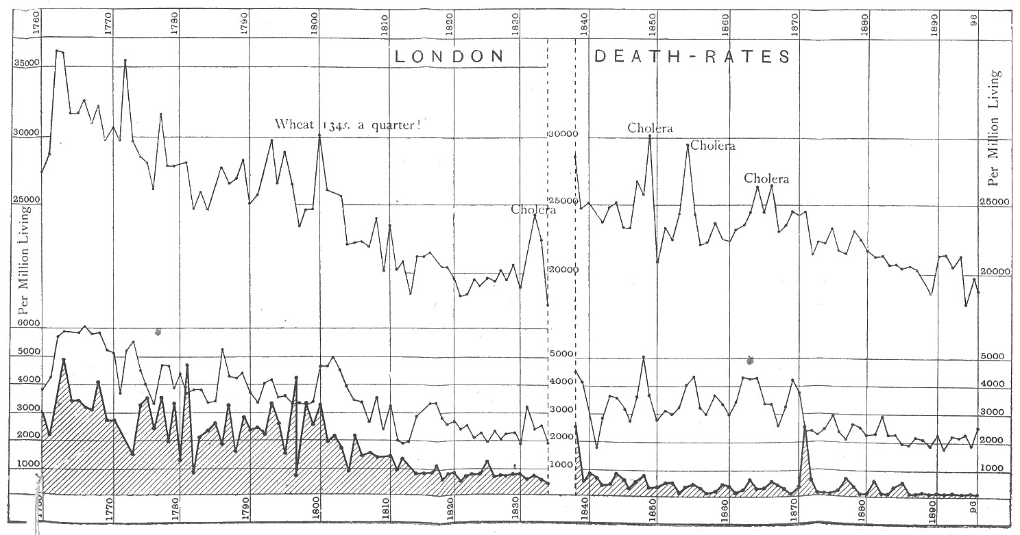
DIAGRAM II.
SHOWING DEATH-RATES FROM THE CHIEF ZYMOTIC DISEASES IN LONDON FROM 1838 TO 1896.
From the Registrar-General's Annual Summary, 1896. Table 14, page xxxiii., and 1888. Table 12, for first nine years. These diagrams show the same facts as Dr. Whitelegge's. Diagram E in Sixth Report of the Royal Commission, p. 660, but in a simpler form.
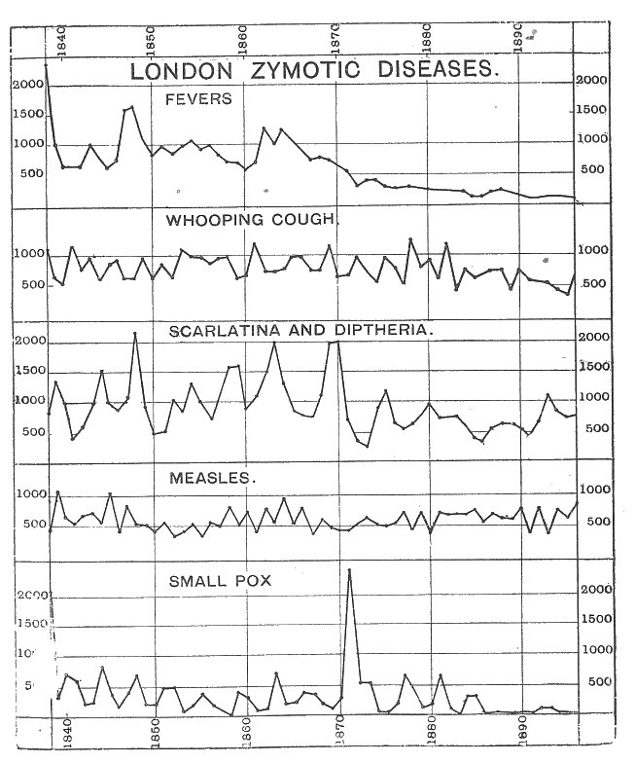

DIAGRAM III.
SMALL-POX, VACCINATIONS, ZYMOTICS, AND TOTAL DEATH-RATE
IN ENGLAND AND WALES.
Small-pox from Final Report, Table B, p. 155, and Regis-
trar-General's Report, 1895, Table 24.
Vaccinations from Final Report, p. 34.
Zymotic diseases from Registrar-General's Report (1895),
Table 24, Columns 3 to 9.
Total Death-rate from Registrar-General's Report, 1895,
Table 3.
N. B.—Each of the lines showing Death-rates has its own
vertical scale showing the rate per million living, in order to
allow of the four separate rates being shown on one diagram
so that their corresponding rise or fall may be compared.

Diagram III.
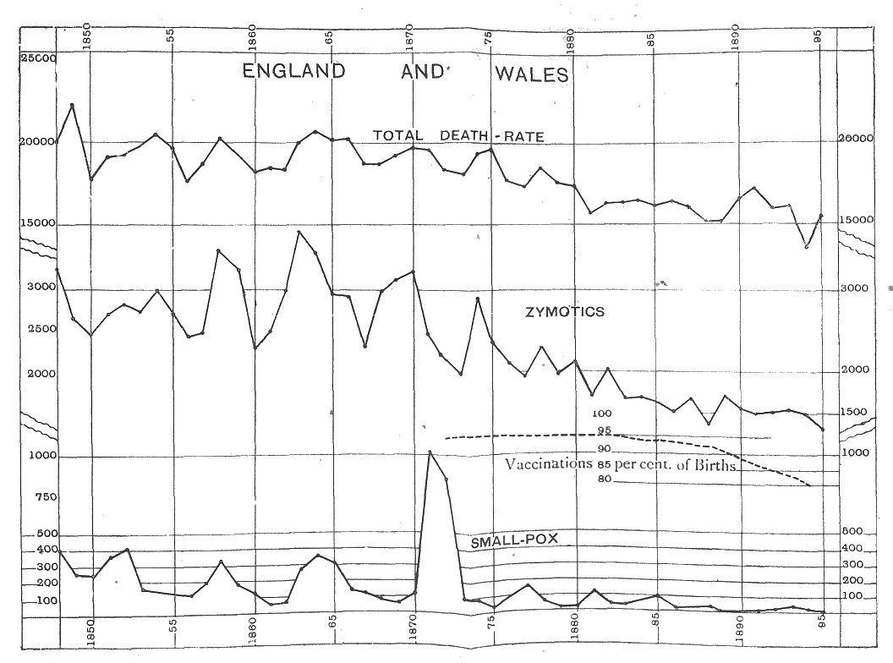
DIAGRAM IV.
COMPARISON OF SCOTLAND AND IRELAND AS REGARDS THEIR DEATH-RATES FROM SMALL-POX AND TWO ZYMOTICS (MEASLES AND SCARLET FEVER).
From Tables given in the Royal Commission's Final Report. (See pages 35, 37, 42, and 44. Solid lines. Small-pox (shaded for distinctness).
Dotted lines. Two Zymotics. Both per million living.
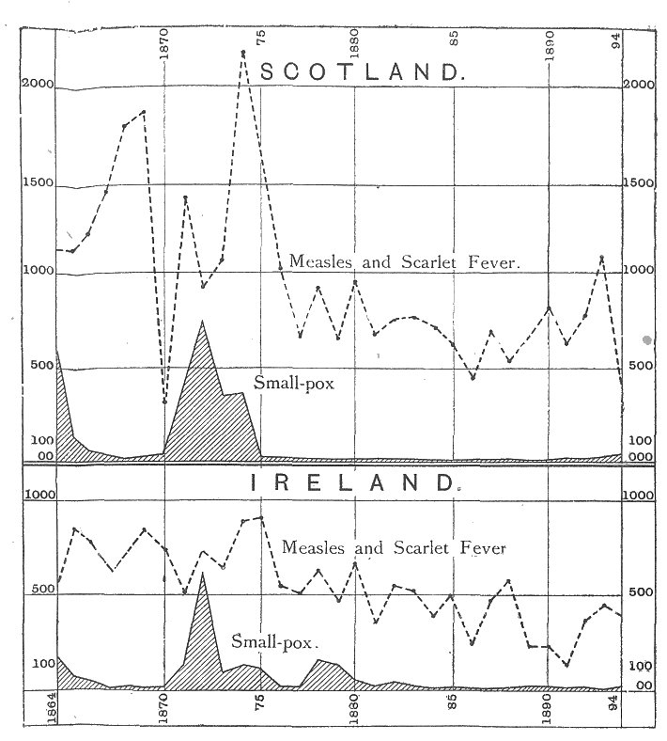

DIAGRAM V.
Sweden:—small-pox and total death-rates, and
stockholm small-pox epidemics.
These death-rates have been calculated by myself from the
official tables of Small-pox and total deaths, and populations
in the Sixth Report, pp. 752-53.
The portion relating to Small-pox agrees with Diagram D,
p. 129, in the Third Report of the Commission, but comes to a
later date. The figures for the Stockholm epidemics are not
given in the Reports of the Royal Commission except as
regards the last and greatest of them. The others are from
the same authority as in my former diagram—Dr. Berg, head
of the Statistical Department at Stockholm, who supplied
them to Dr. Pierce, as stated in his " Vital Statistics."
The Upper line, showing the death-rate from all causes, is
from the five-year average mortality, and is on a smaller ver-
tical scale (as shown by the figures at the sides) in order to
bring it into the same diagram.

Diagram V.
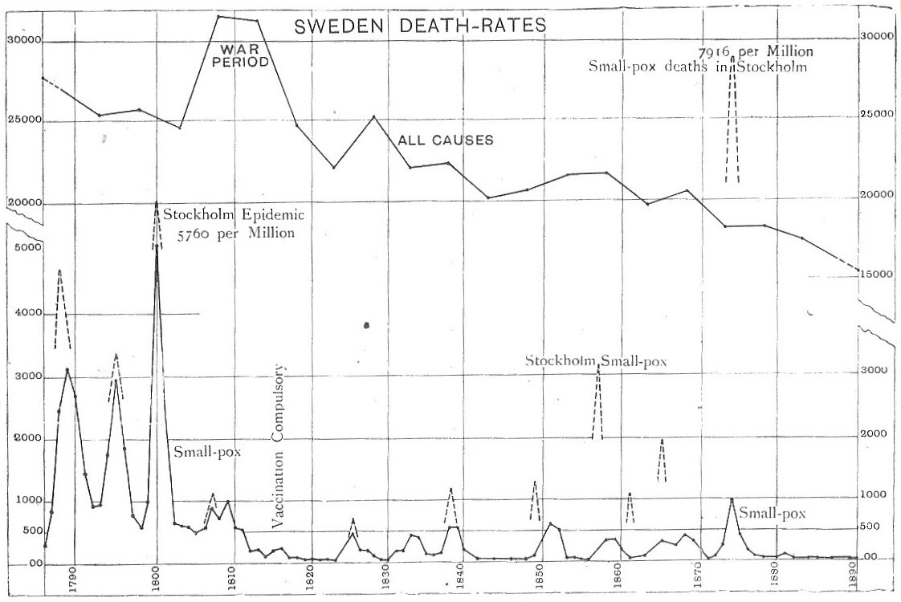
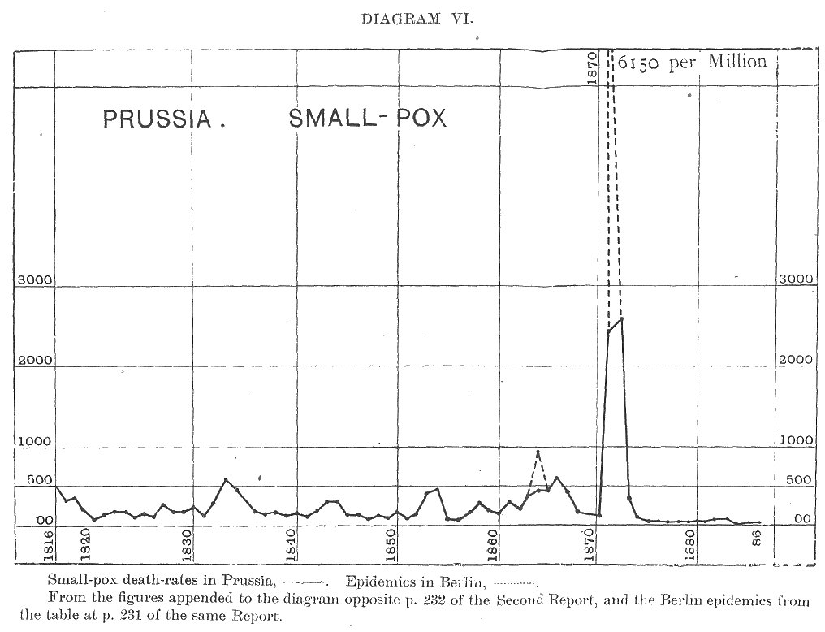
DIAGRAM VII.
BAVARIA.—MORTALITY FROM SMALL-POX AND OTHER ZYMOTIC DISEASES IN THE YEARS 1858 TO 1873.
From Tables in the Second Report, pp. 337-38. Bavaria is chosen by Dr. Hopkirk to show the advantages of compulsory vaccination (see Q. 1489, p. 11, and Table facing p. 238, of Second Report).
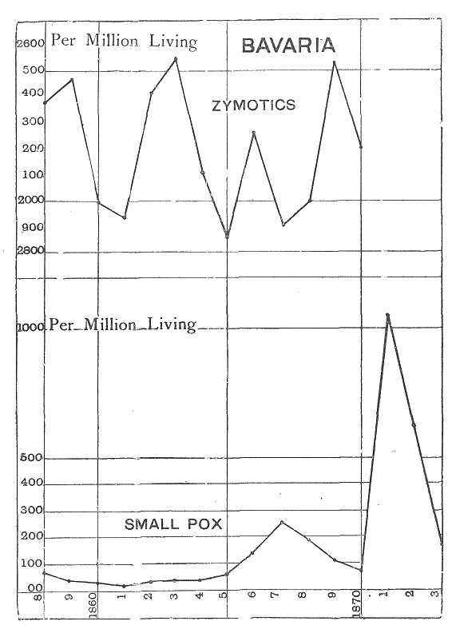

DIAGRAM VIII.
SHOWING THE DEATH-RATES PER MILLION LIVING BY SMALL-
POX AND ZYMOTIC DISEASES, FROM 1838 TO 1896, IN
LEICESTER.
The dotted line shows the percentage of Vaccinations to
Births.
N. B.-- Before 1862 private vaccinations have been
estimated.
The Upper Thick line shows the death-rate from the follow-
ing diseases: Measles, Scarlet Fever, Diphtheria, Typhus,
Whooping-cough, Enteric and other Fevers.
The Lower Line, shaded for distinctness, shows the Small-
pox death-rate.
Drawn from Mr. Thomas Biggs' Table 19, at p. 440 of the
Fourth Report, kindly continued by Mr. Biggs to 1896.
Diagram VIII.
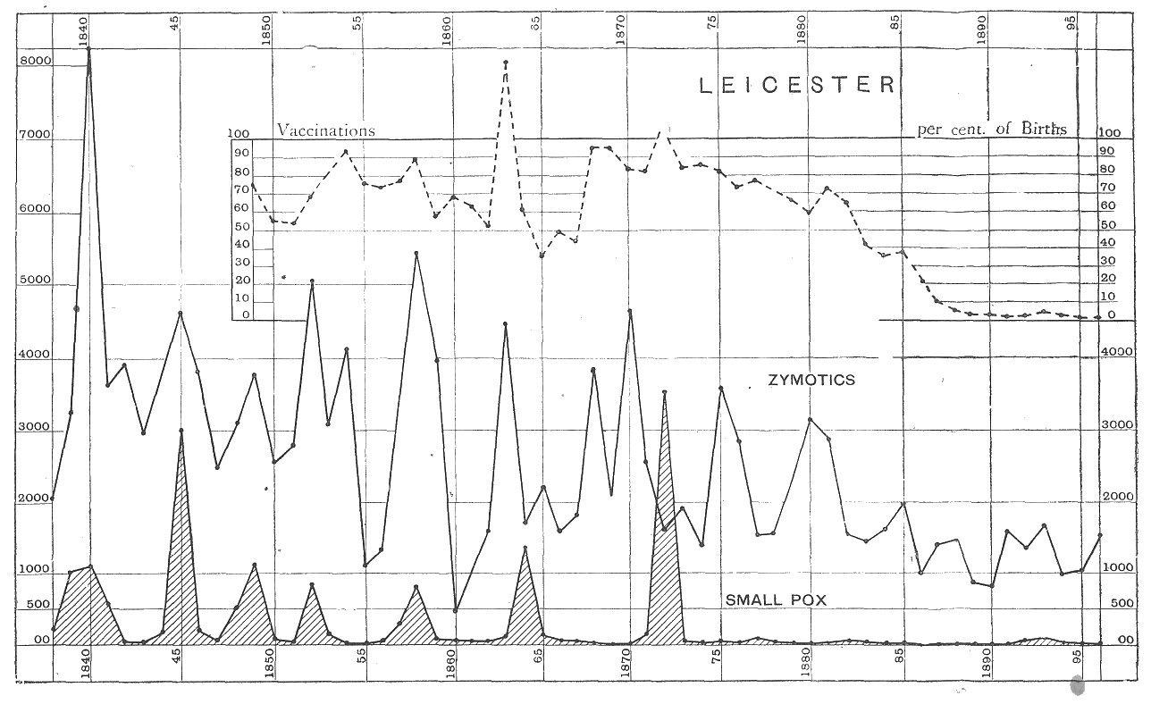
DIAGRAM IX.
THIS DIAGRAM SHOWS VARIOUS DEATH-RATES IN LEICESTER, IN FIVE-YEAR AVERAGES.
The dotted line shows the percentage of vaccinations to total births.
Authorities.
The three Death-rates and the Vaccinations are from Table 34 (p. 450) in the Fourth Report.
The Small-pox Death-rate is from Table 45 (p. 461) in same Report. Figures to continue the diagram to 1896 have been kindly
furnished by Mr. Biggs from official sources.
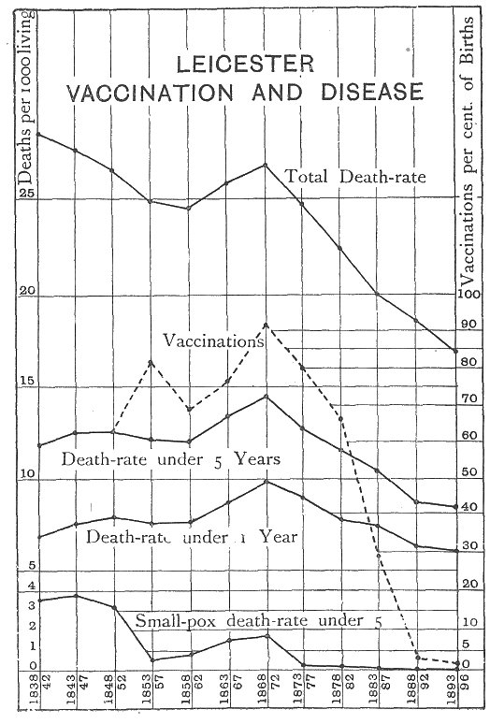

DIAGRAM X.
INFANT MORTALITY.
The upper portion of this diagram shows the Infant Mor-tality of London from 1730 to 1830, from Dr. Farr's tables in McCulloch's " Statistical Account of the British Empire," vol. i. p. 543 (1847). From 1840 to 1890 shows the Infant Mortality of England, calculated from the Reports of the Registrar-General (see Third Report, p. 197, Table O). Materials for the continuation of Dr. Farr's London Table (under five years) are not given by the Registrar-General. The Lower part of the Table shows, on a larger scale, the Infant Mortality of London, under one year, as given by the Registrar-General in his Annual Summary for 1891, Table 12, p. xxv. and in his Fifty-eighth Annual Report, Table 25,
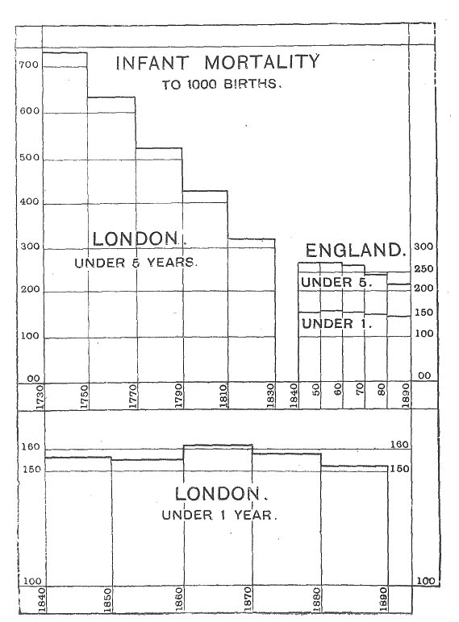

DIAGRAM XI
ARMY AND NAVY.
Lower Thick line shows the Small-pox mortality per
100,000 in the Army.
Upper Thick line shows the total Disease Mortality in the
Army (Home Force).
The two Thin lines show the corresponding Mortalities in
the Navy.
Authorities.
Total Disease Mortalities, from the Registrar-General's
Fifty-first Report, Table 29, and Fifty-eighth Report, Table
33, for the Army. From Table at p. 25-1 of Second Report of
Royal Commission for the Navy.
Small-pox Mortalities from the " Final Report," pp. 86-88.
N. B.—The higher figures (hundreds) show the Disease mor-
tality; the lower figures (tens) show the Small-pox mortality
per 100,000.

Diagram XI.
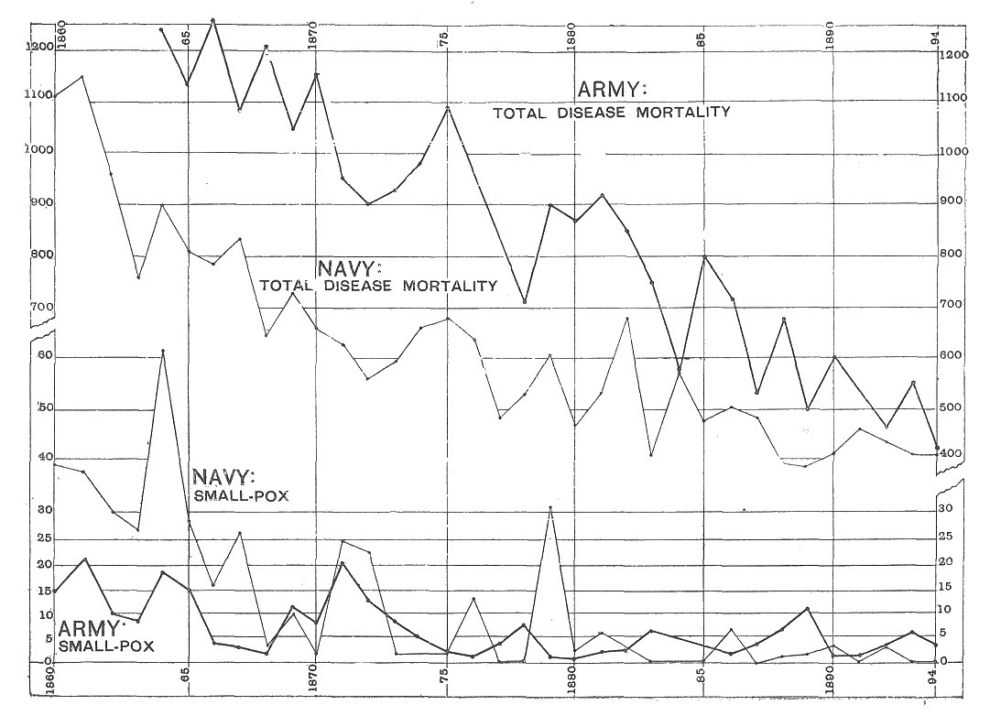
DIAGRAM XII.
SMALL-POX MORTALITY PER 100,000.
The Army and Navy as compared with Ireland.
From the earliest year given for Ireland in the Reports of
the Royal Commission.
Authorities.
Army, Second Report, Table C, p. 278.
Navy, Second Report, Table C, p. 254.
Both supplemented for the last six years by the " Final
Report," pp. 86-88.
Ireland. Table on p. 57 of "Final Report," corrected to
ages 15-45 by adding one-tenth, according to the Table J at p.
274 of Second Report.

Diagram XII.


